Discover Agra with INTRO TRAVELS INDIA
Agra, located in the state of Uttar Pradesh, is one of India’s most iconic travel destinations, famous for the magnificent Taj Mahal, Mughal architecture, rich history, vibrant culture, and delicious food. Situated on the banks of the Yamuna River, Agra attracts millions of travelers from around the world who come to witness the beauty of one of the Seven Wonders of the World.
Whether you are planning a family holiday, romantic getaway, heritage tour, or weekend trip, Agra offers an unforgettable cultural experience.

Why Visit Agra?
- Home to the world-famous Taj Mahal
- Rich Mughal history & architecture
- UNESCO World Heritage Sites
- Beautiful gardens & forts
- Delicious Mughlai cuisine
- Perfect weekend getaway from Delhi
- Great destination for photography & culture lovers

Top Tourist Attractions in Agra
1. Taj Mahal
One of the Seven Wonders of the World and India’s most famous monument.
Built by Mughal Emperor Shah Jahan in memory of Mumtaz Mahal, the Taj Mahal is known for:
- White marble architecture
- Beautiful gardens
- Romantic sunrise & sunset views
- Intricate carvings & craftsmanship
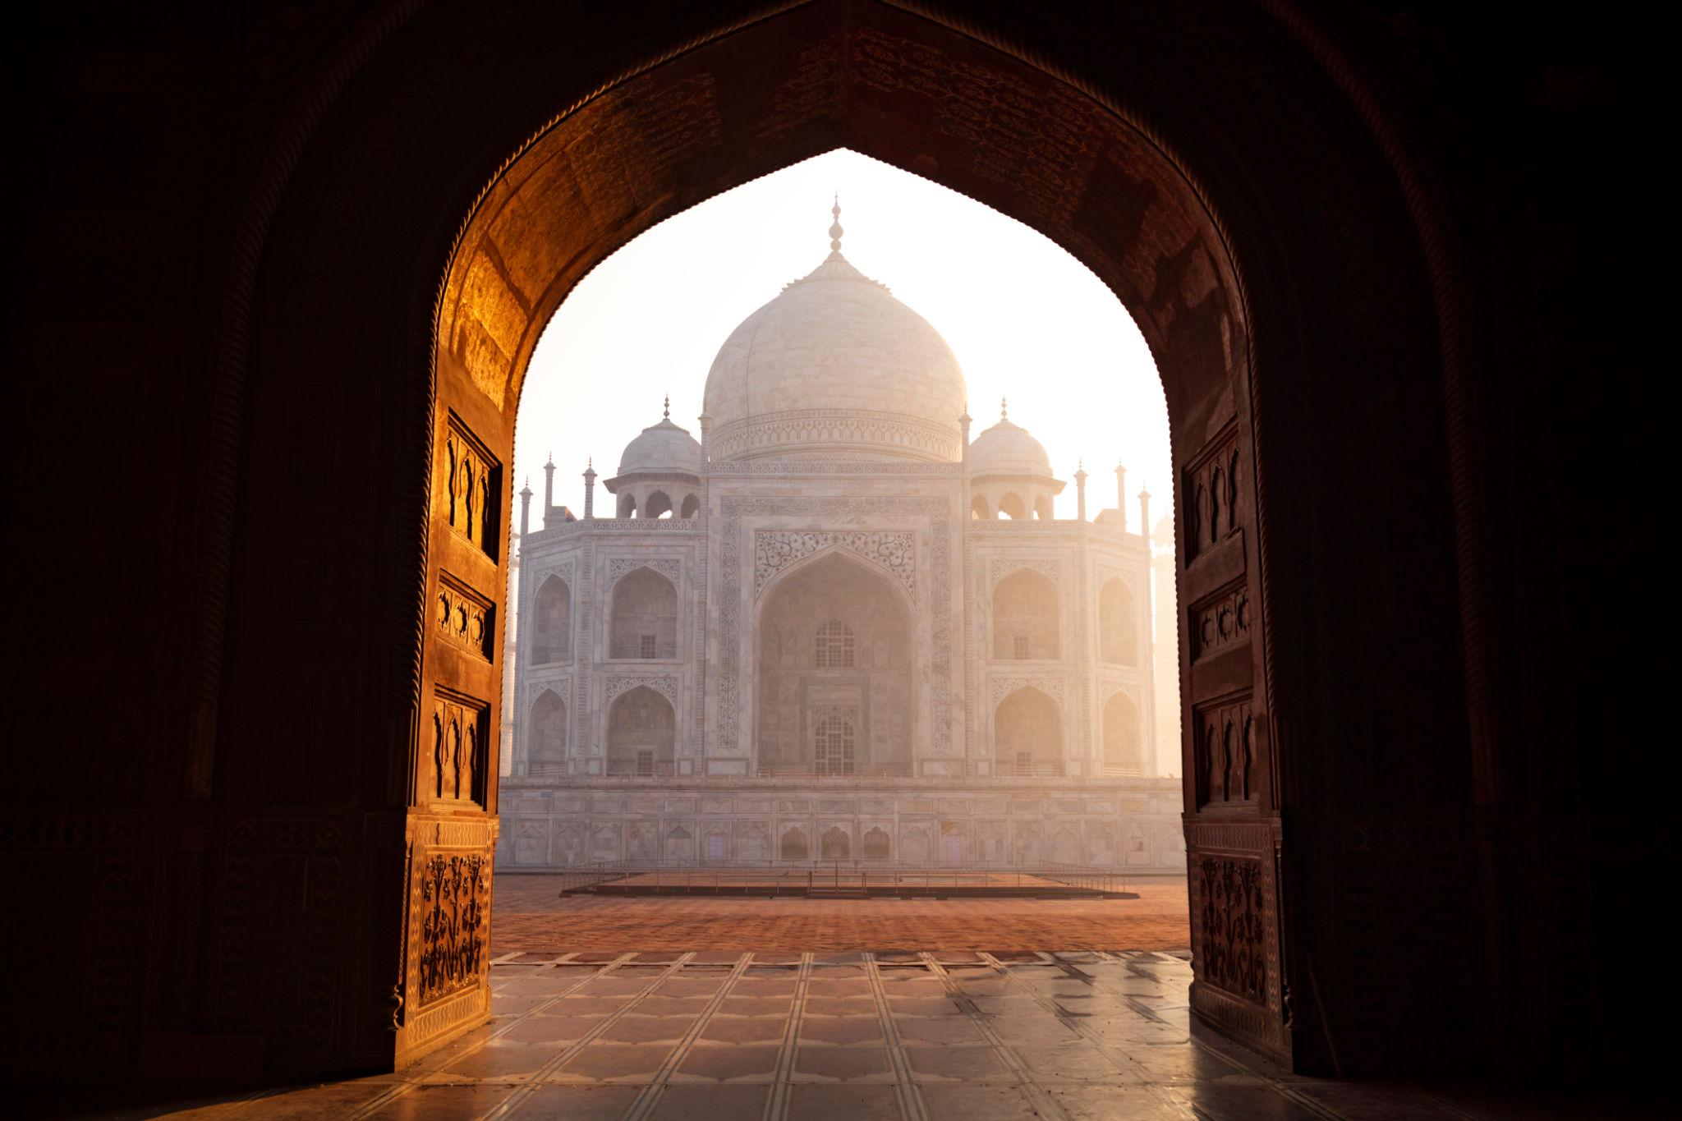
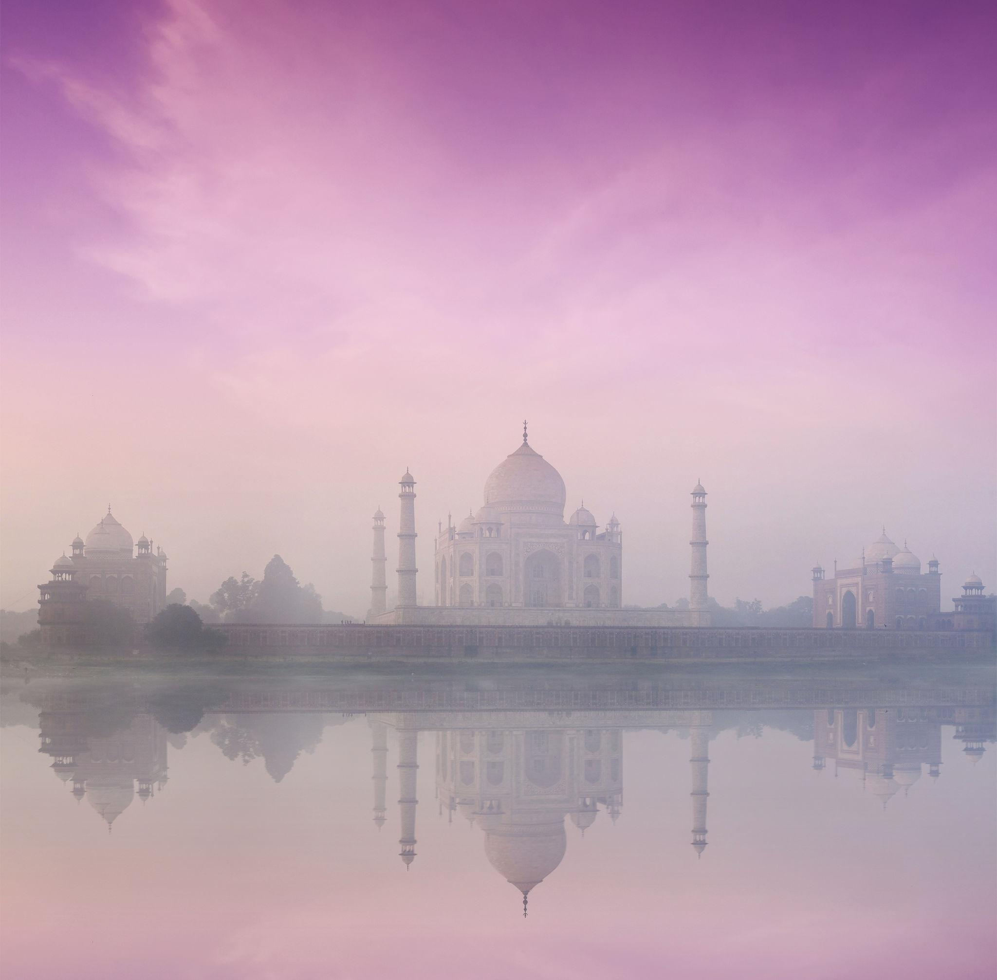
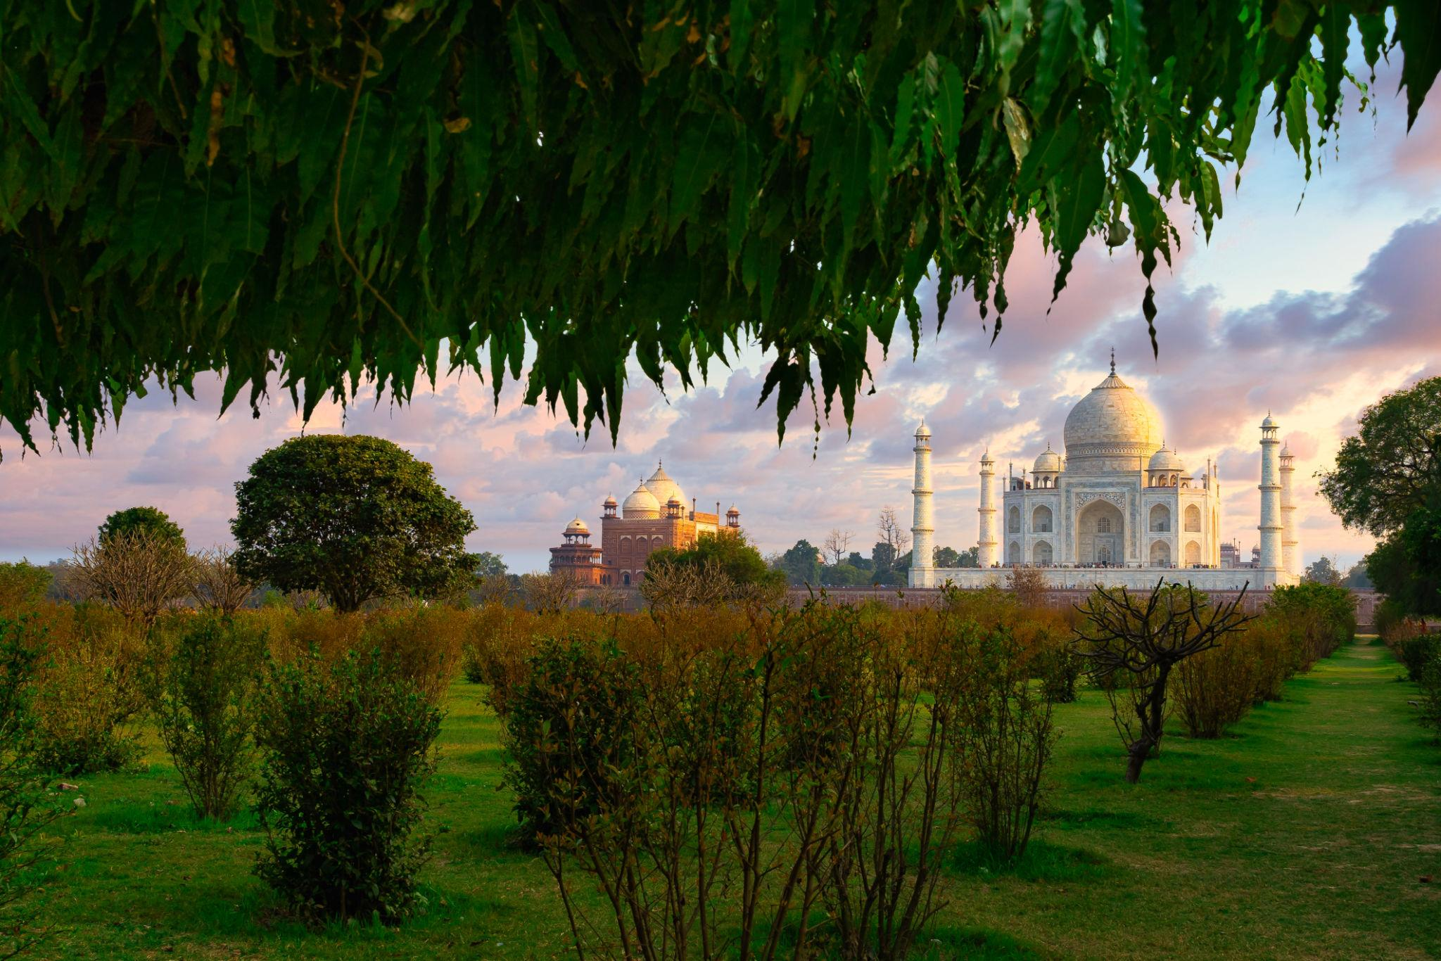
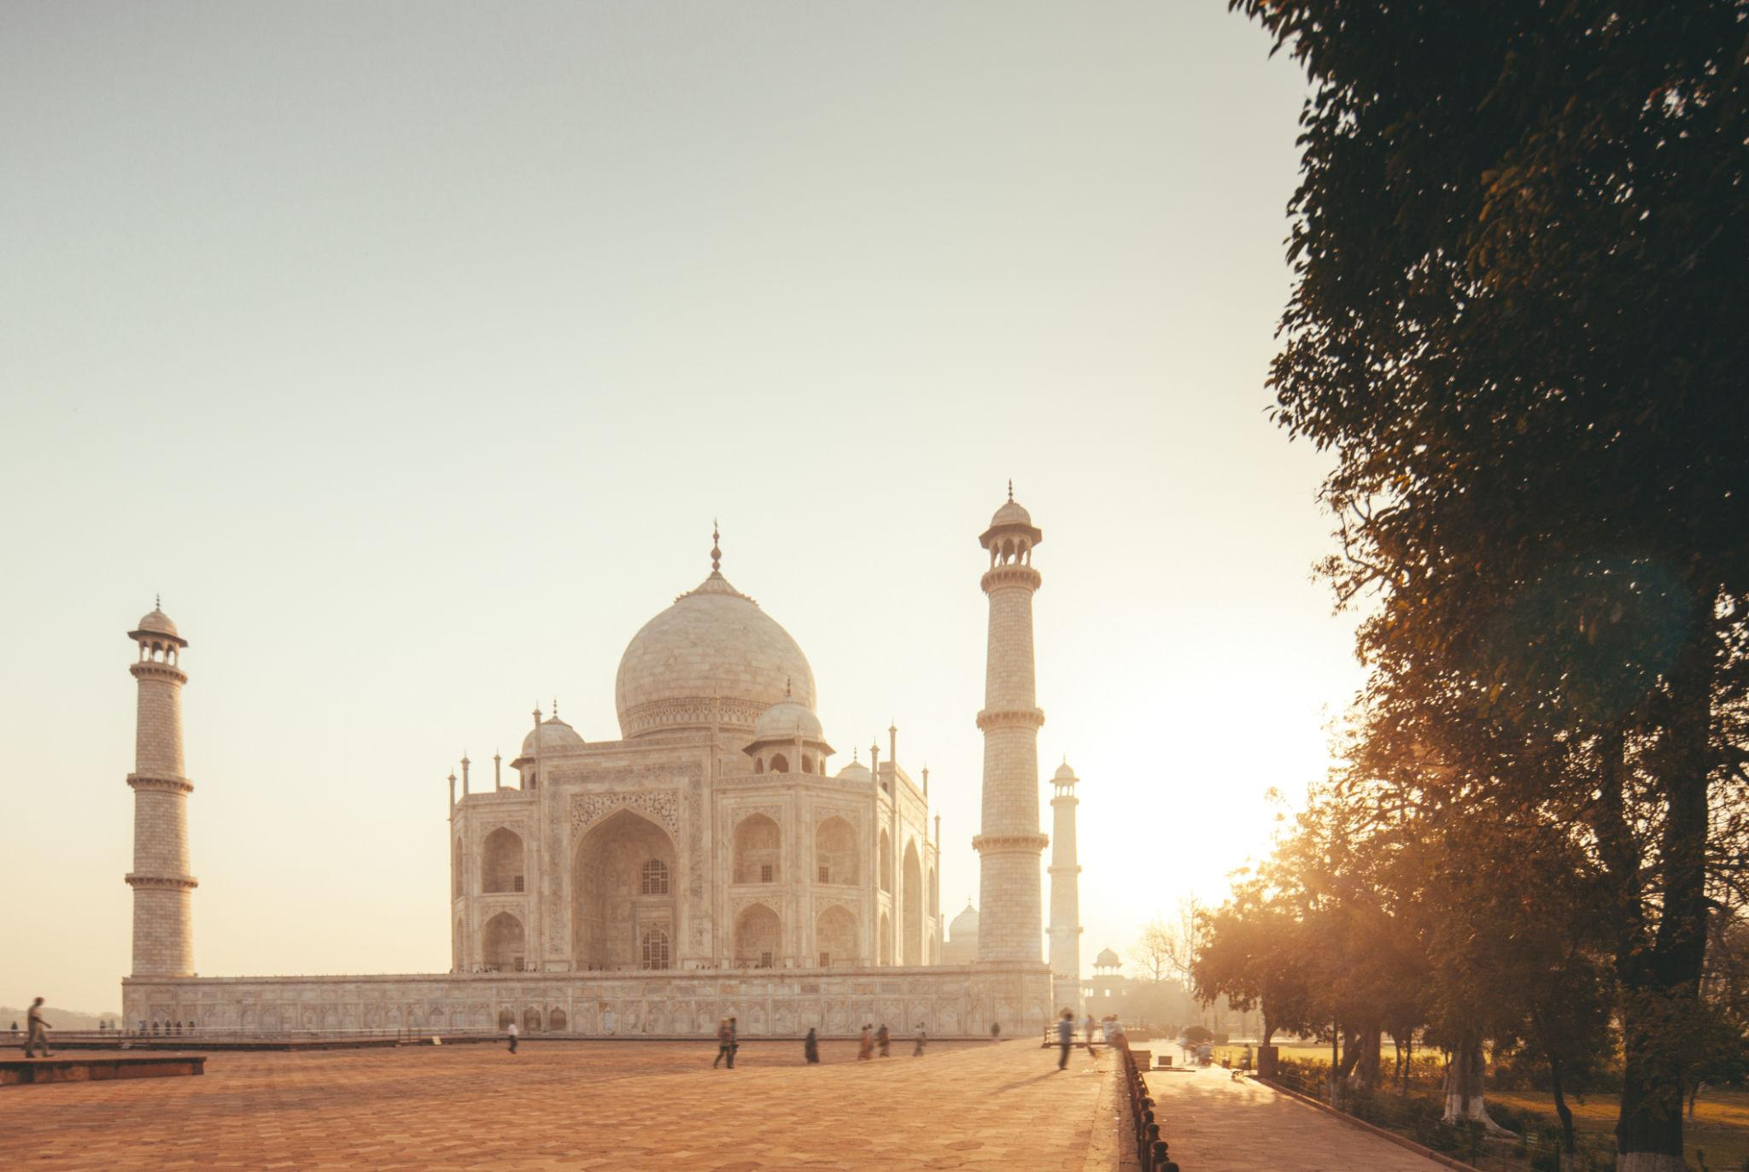
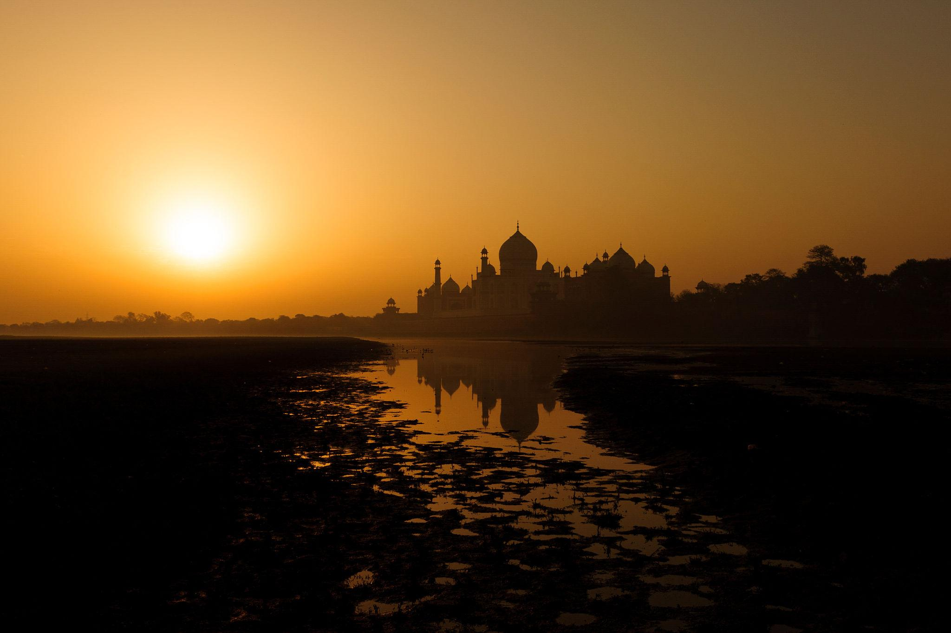
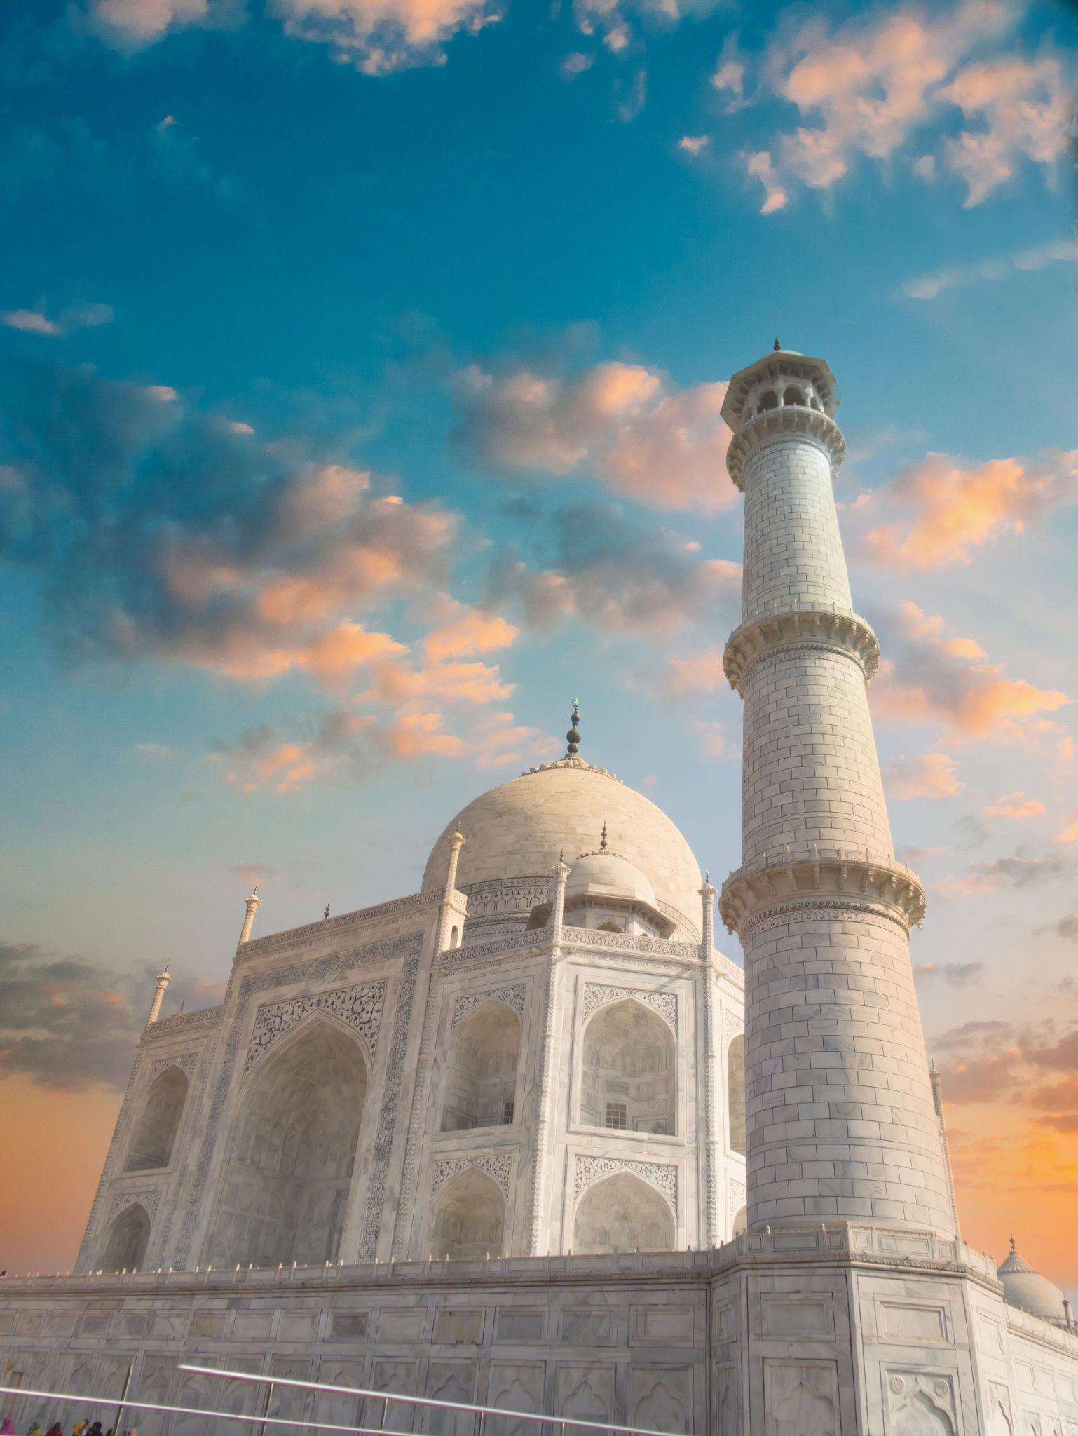

2. Agra Fort
A UNESCO World Heritage Site and one of the finest Mughal forts in India.
Highlights:
- Massive red sandstone walls
- Royal palaces & courtyards
- Historic Mughal architecture
- Views of the Taj Mahal
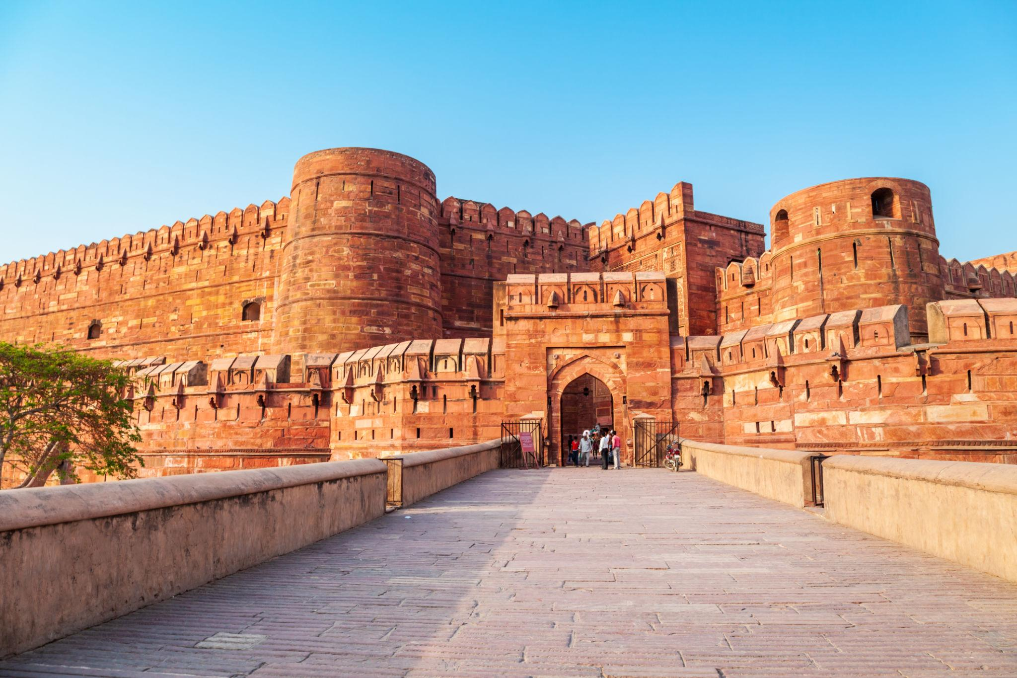
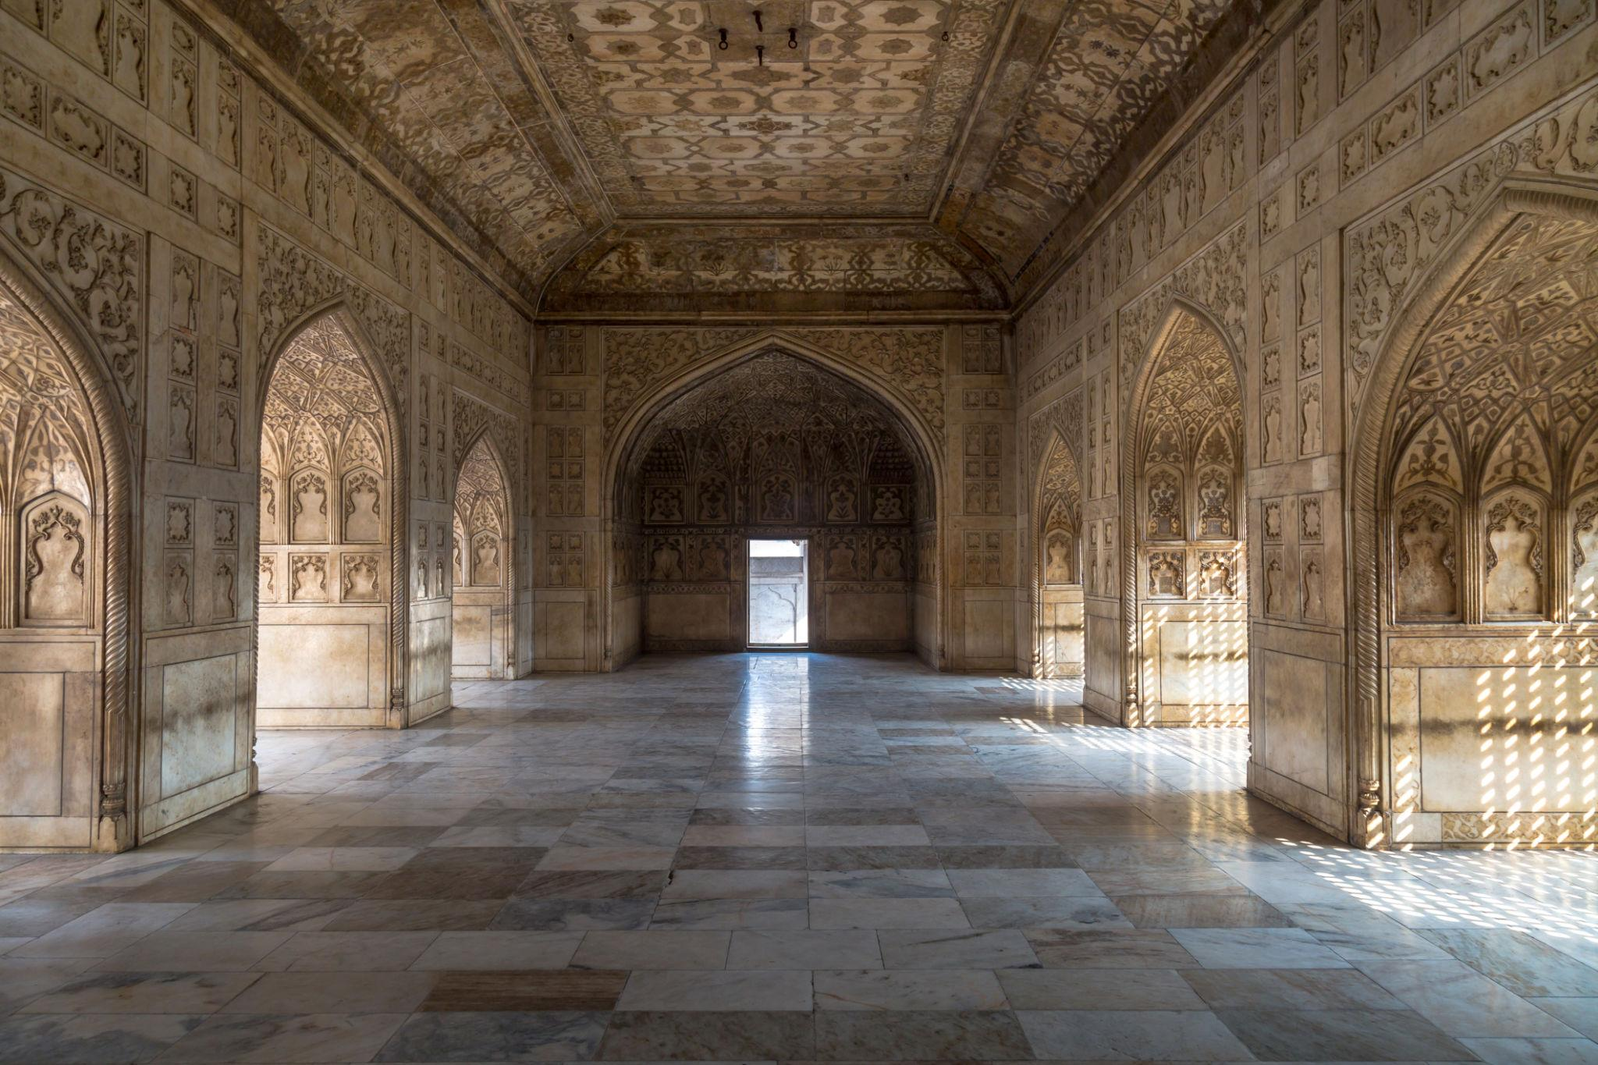
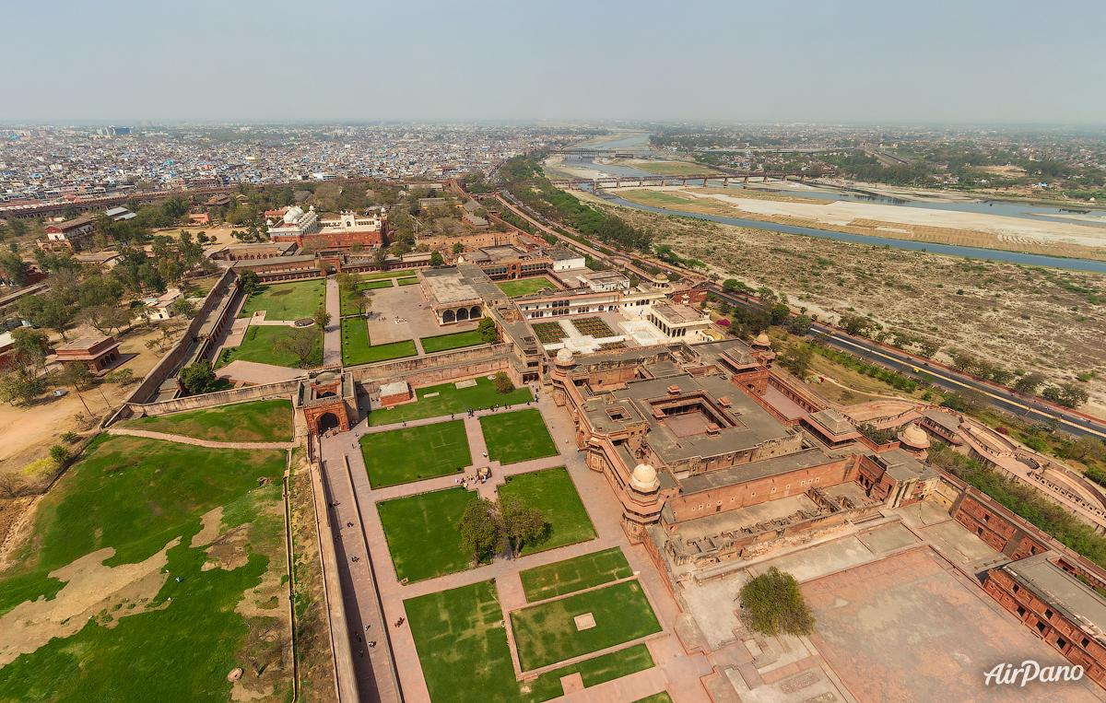
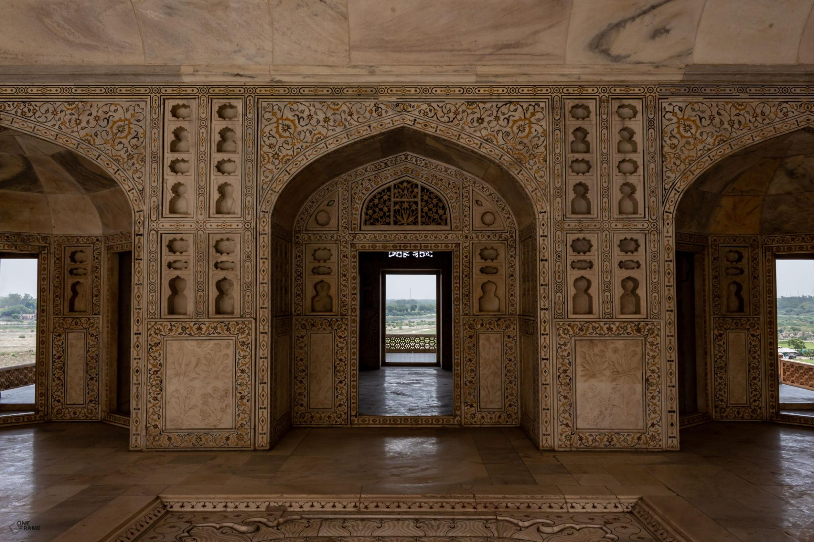
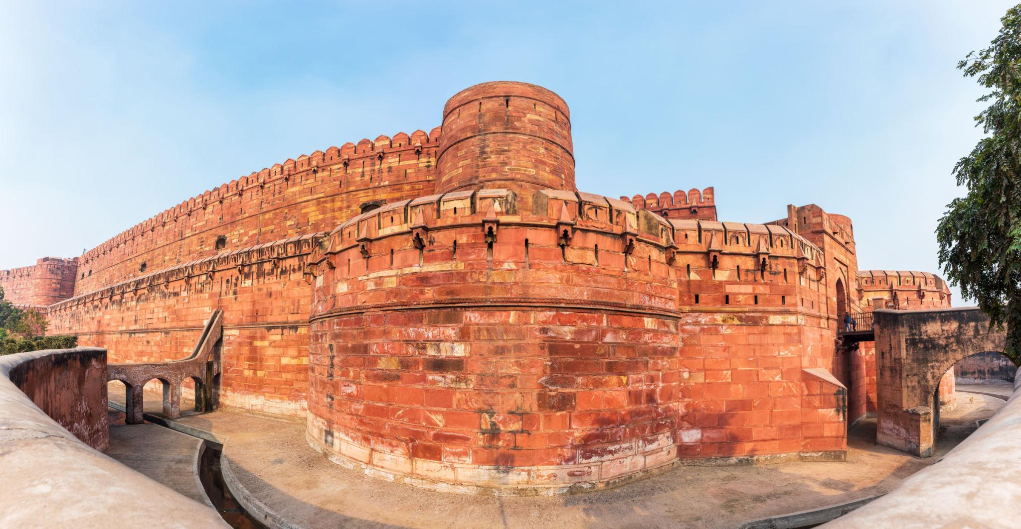
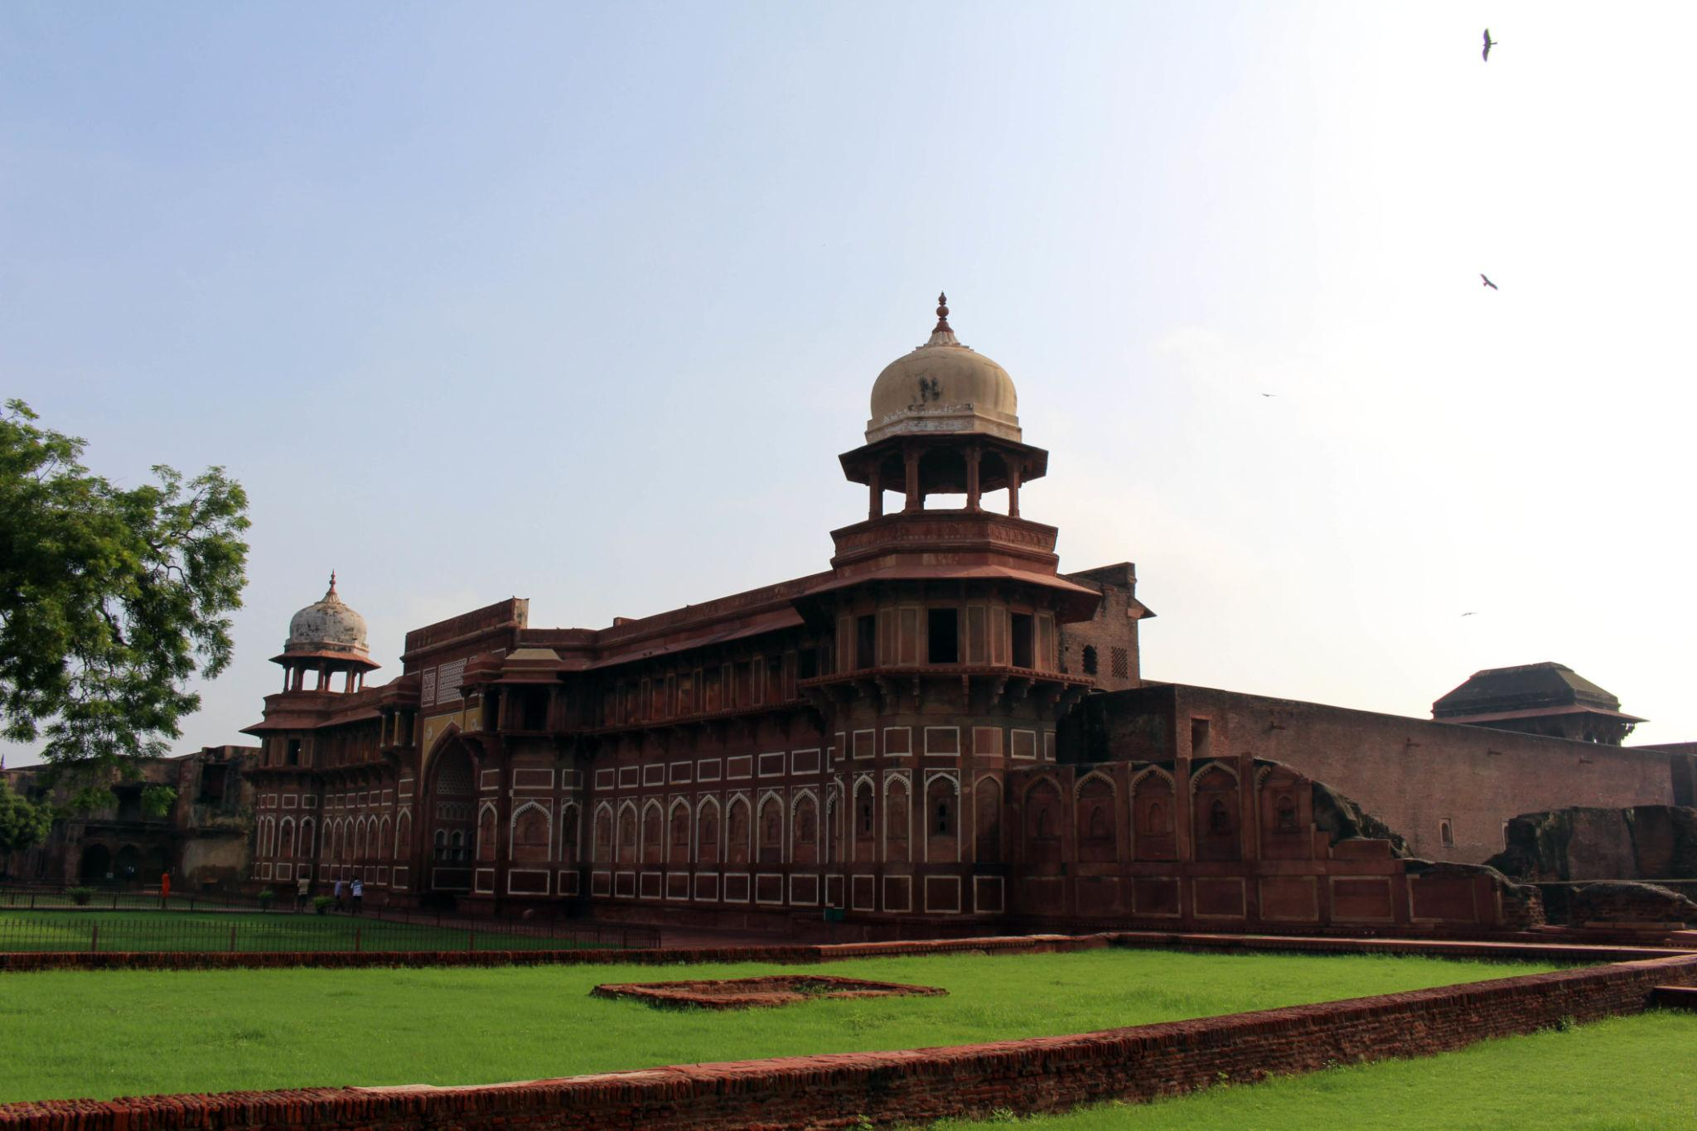
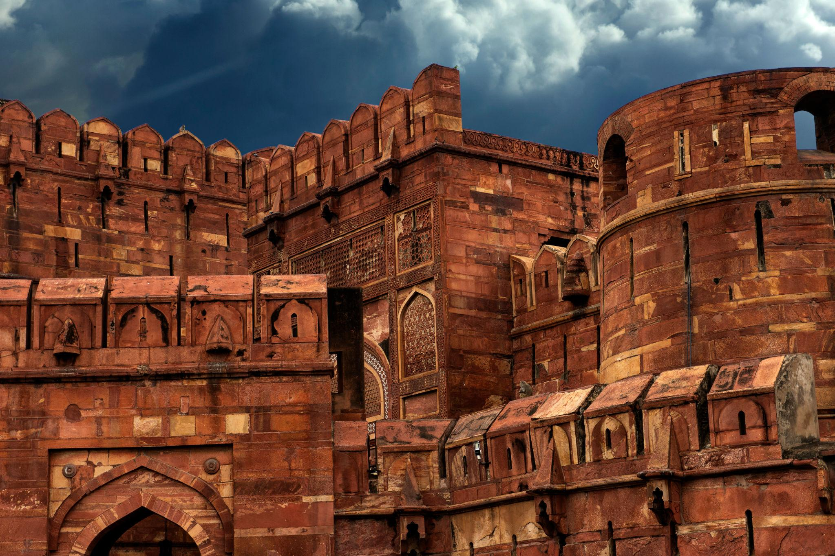

3. Mehtab Bagh
A beautiful garden complex located across the Yamuna River.
Best known for:
- Stunning sunset views of Taj Mahal
- Peaceful atmosphere
- Photography spots
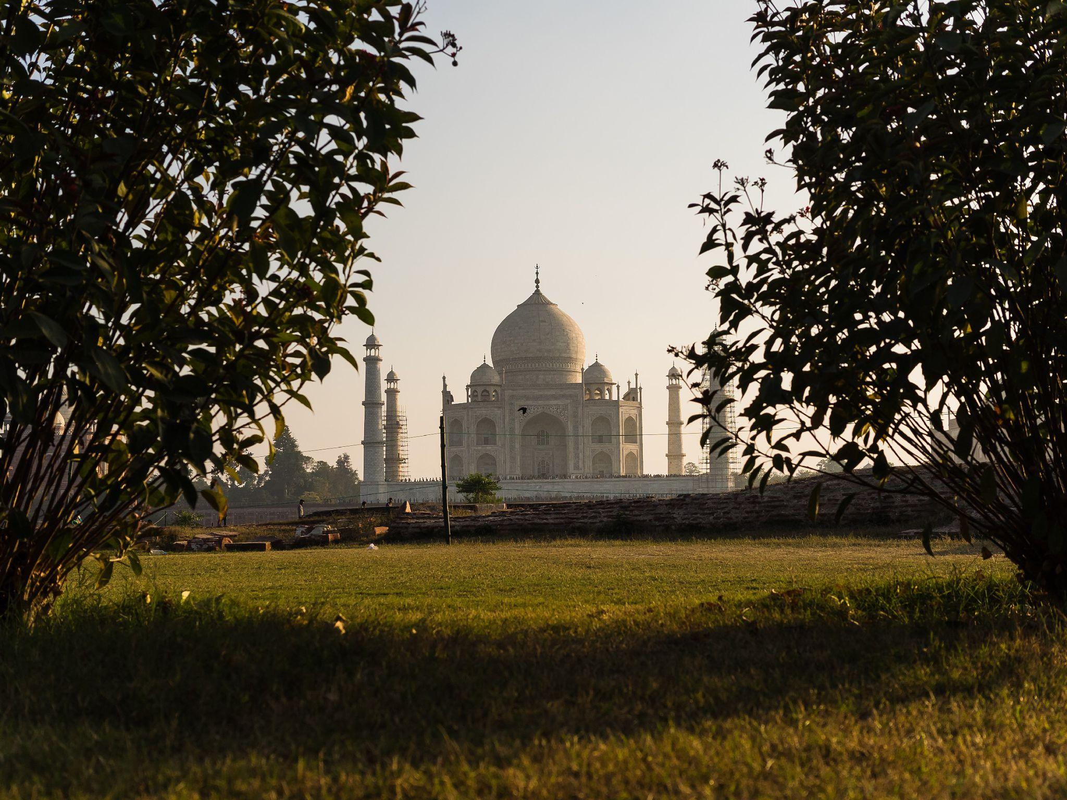
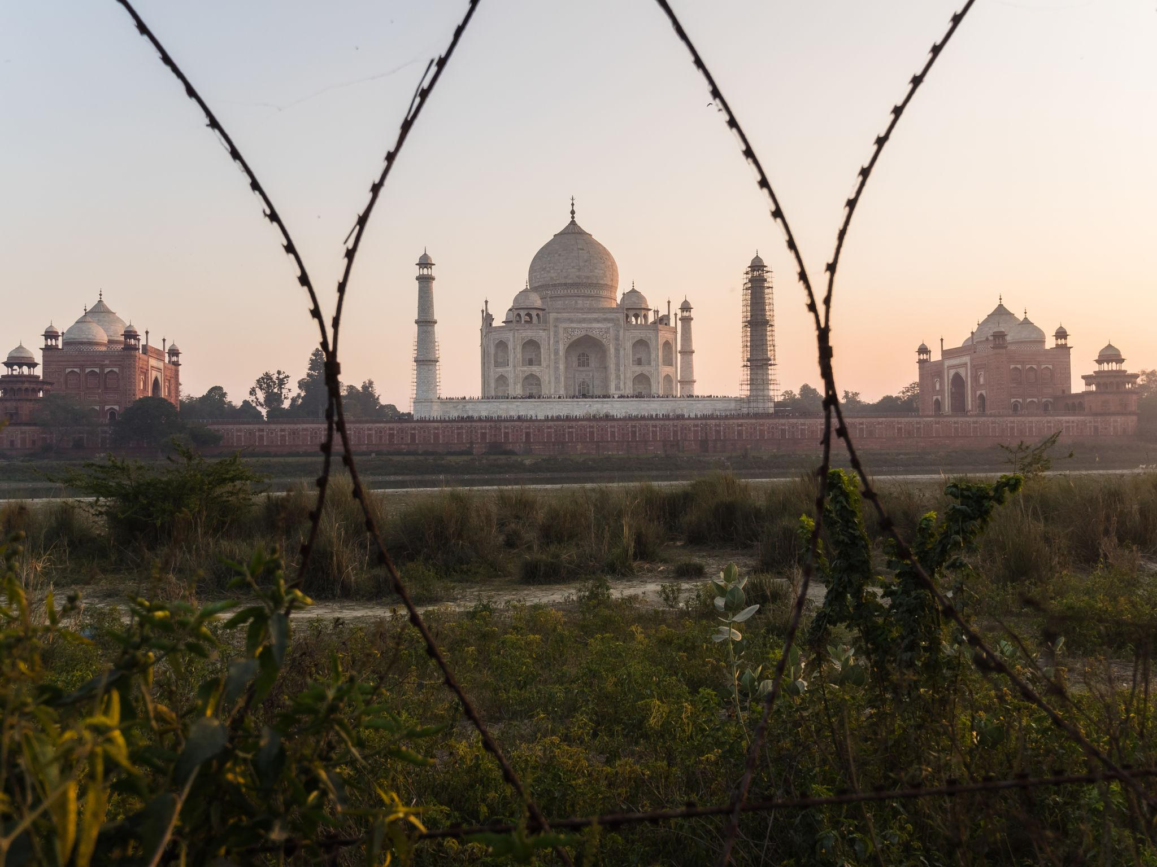

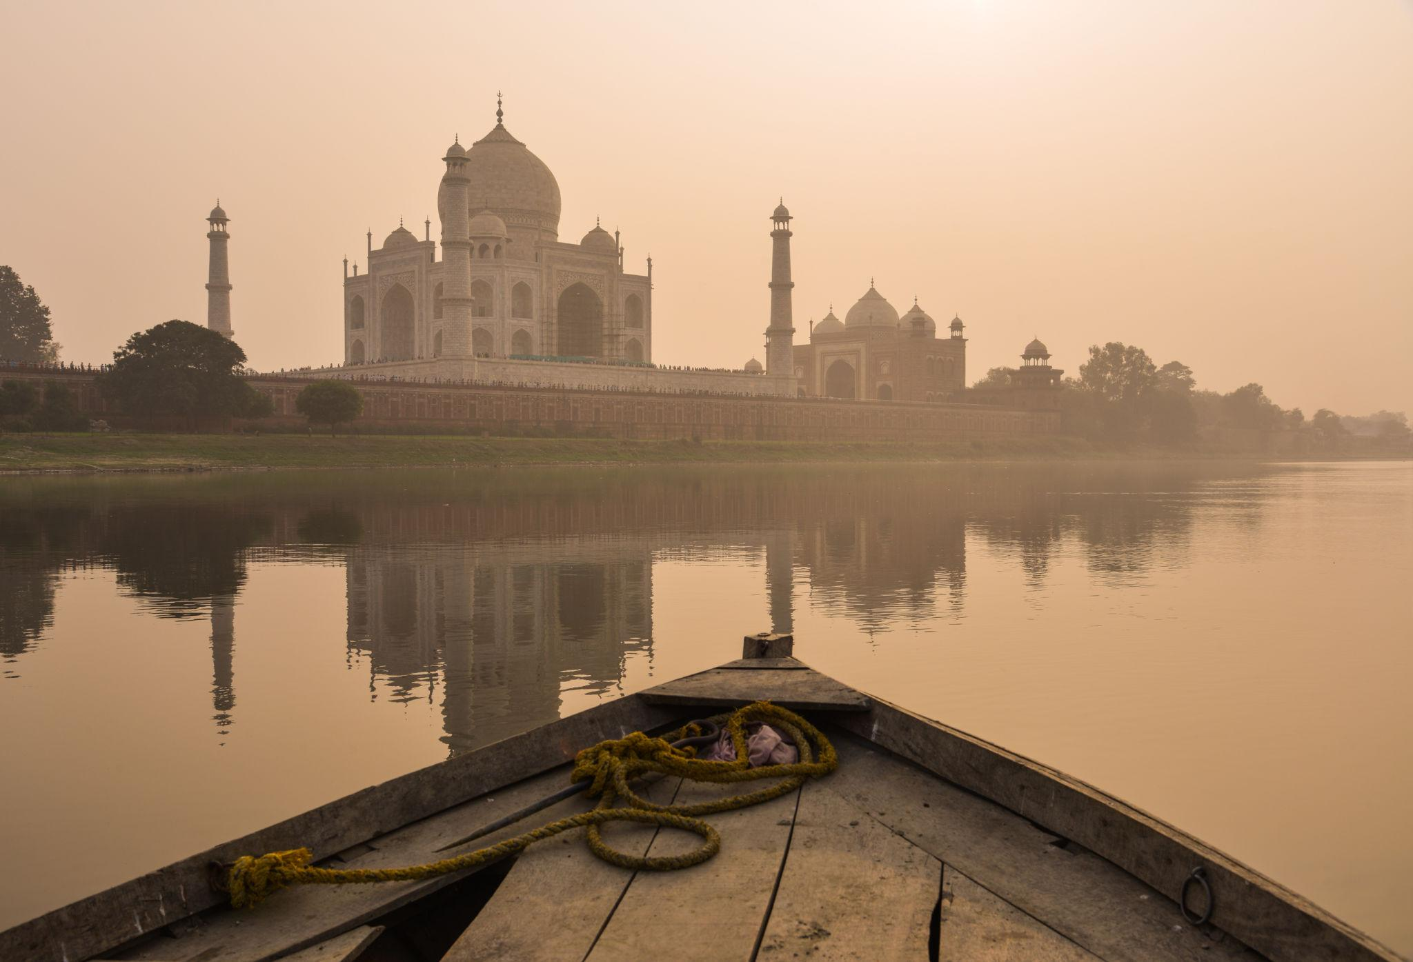

4. Fatehpur Sikri
A historic Mughal city located near Agra.
Top attractions:
- Buland Darwaza
- Jama Masjid
- Royal palaces
- Mughal courtyards
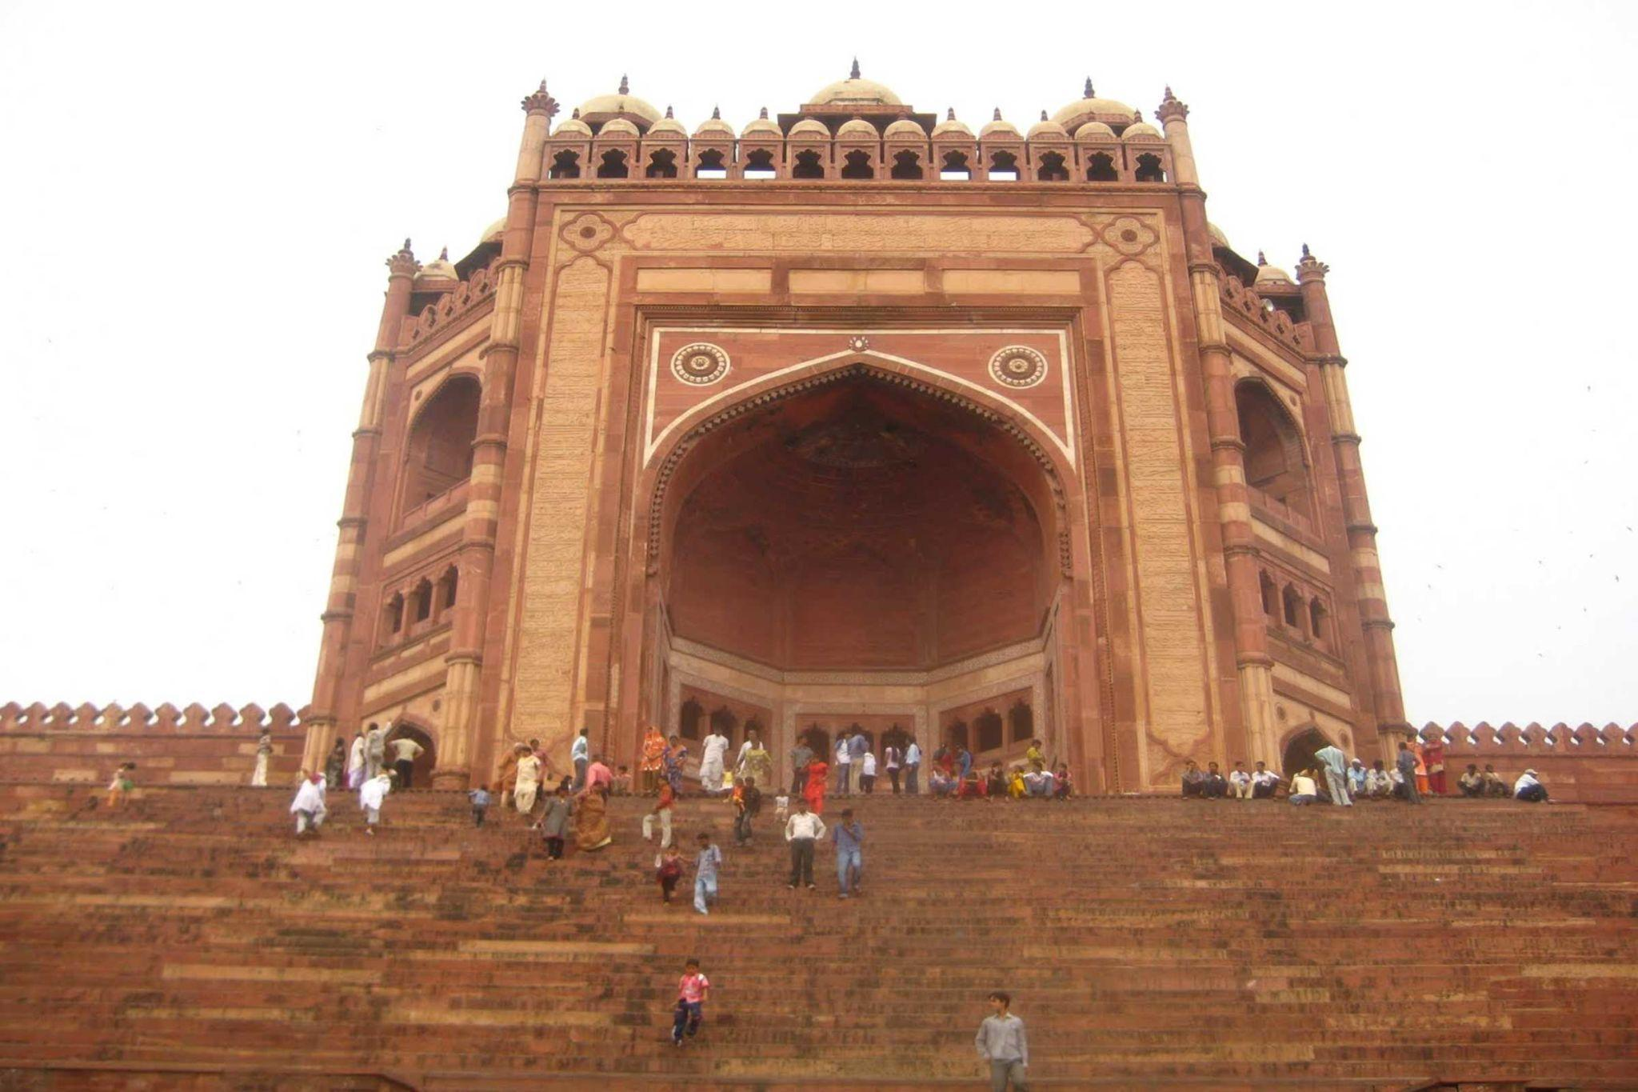
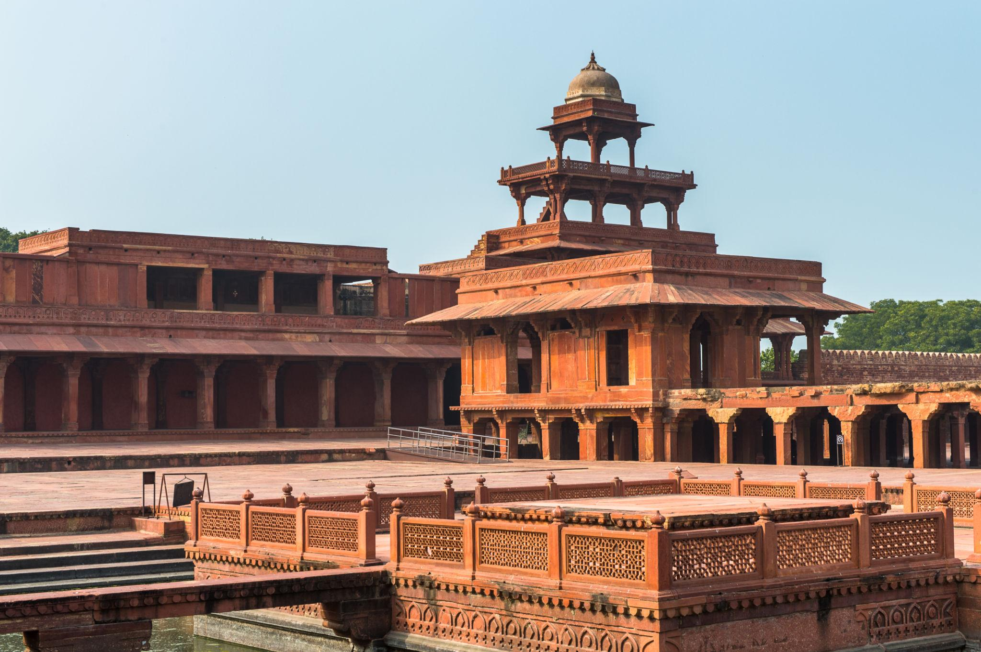
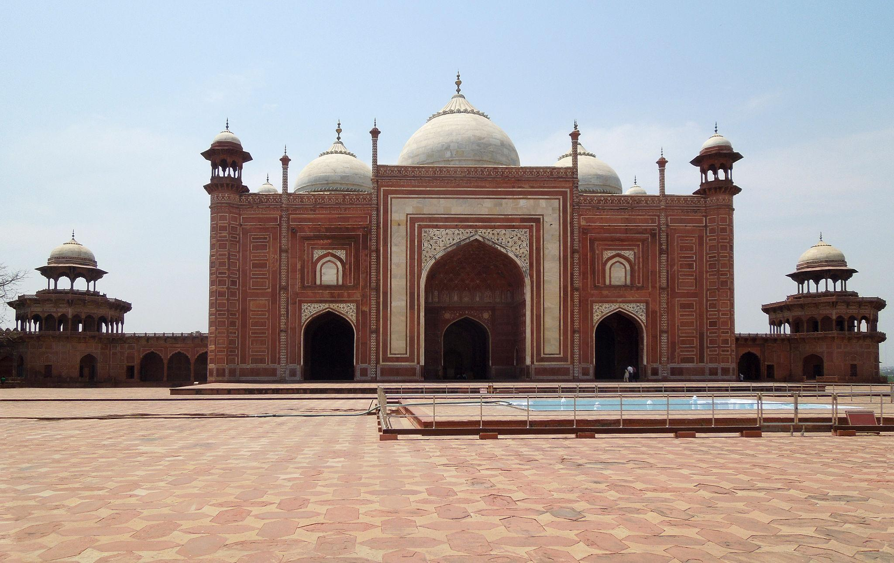
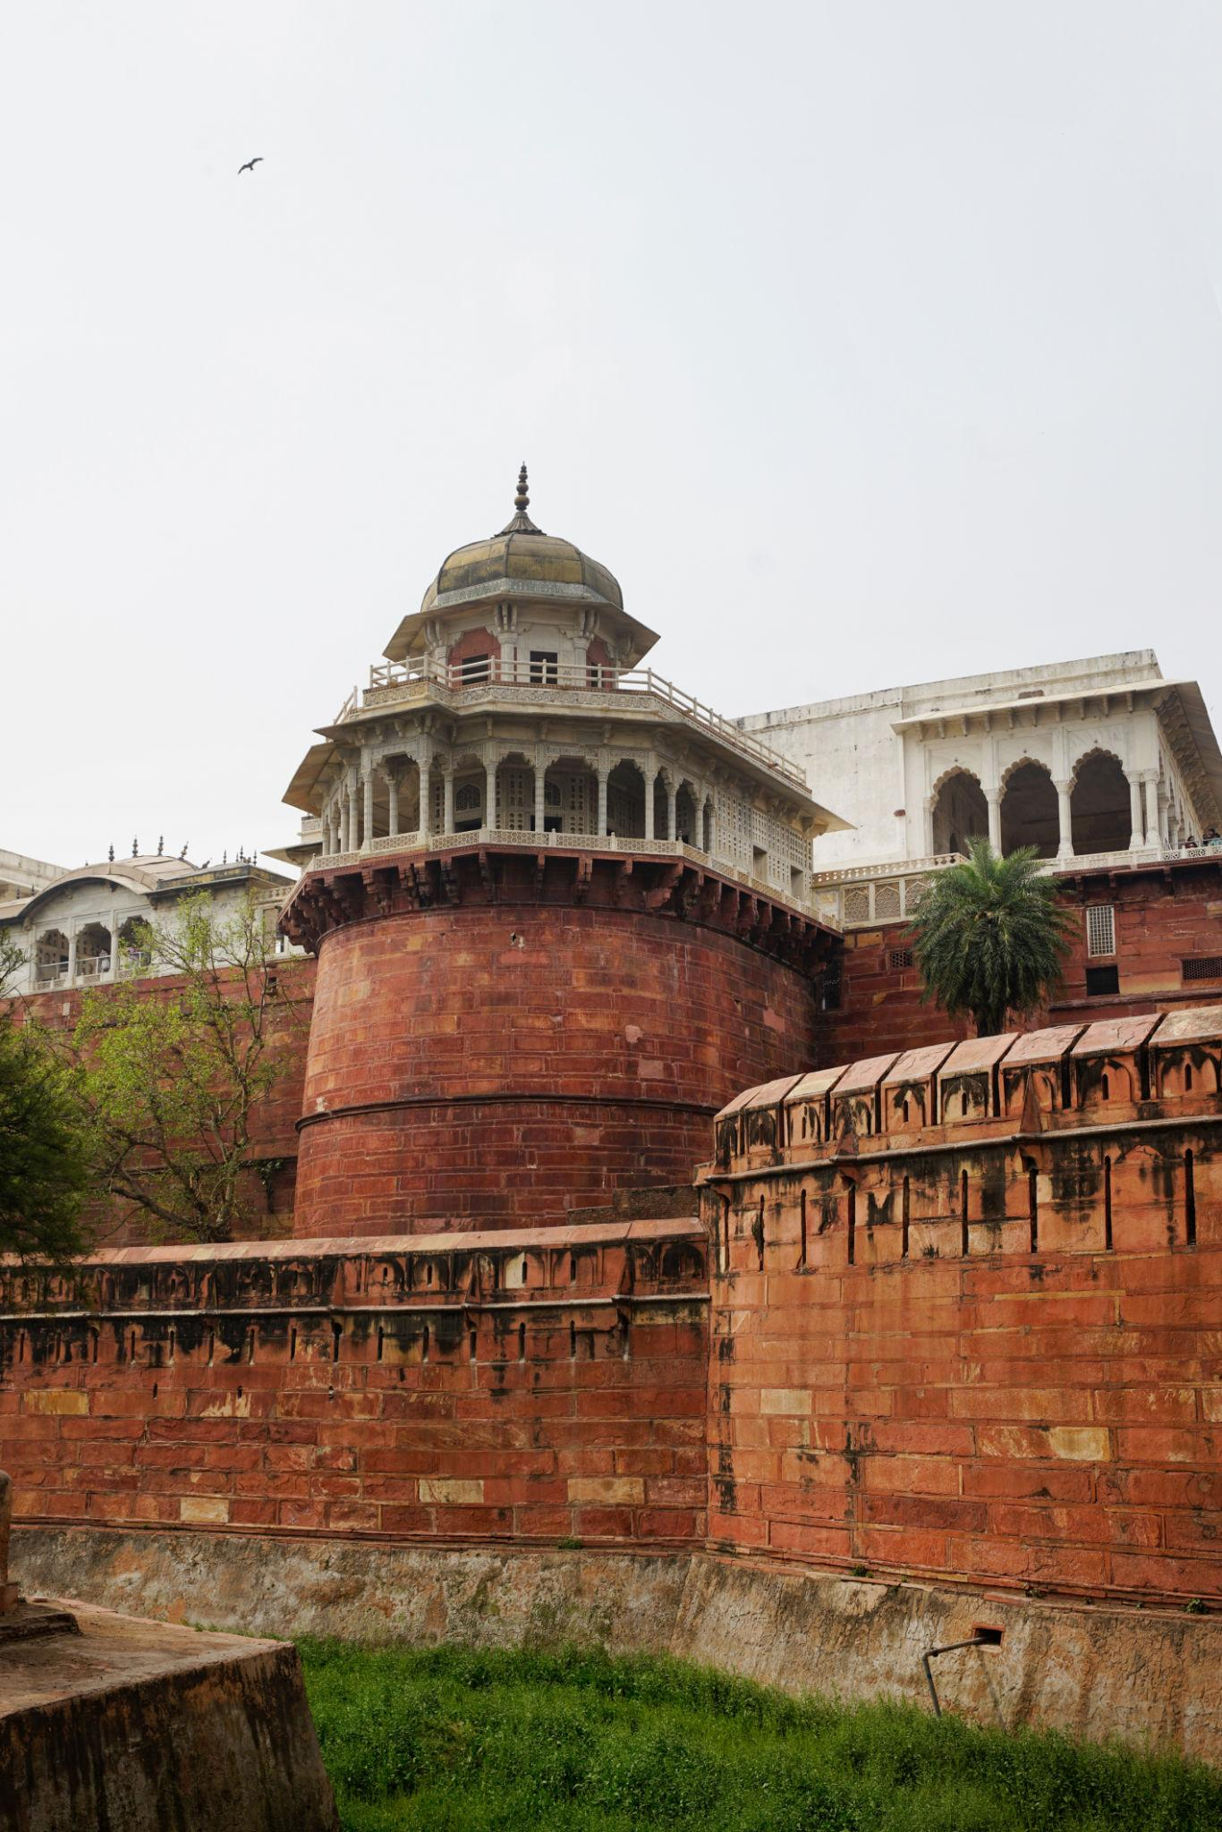
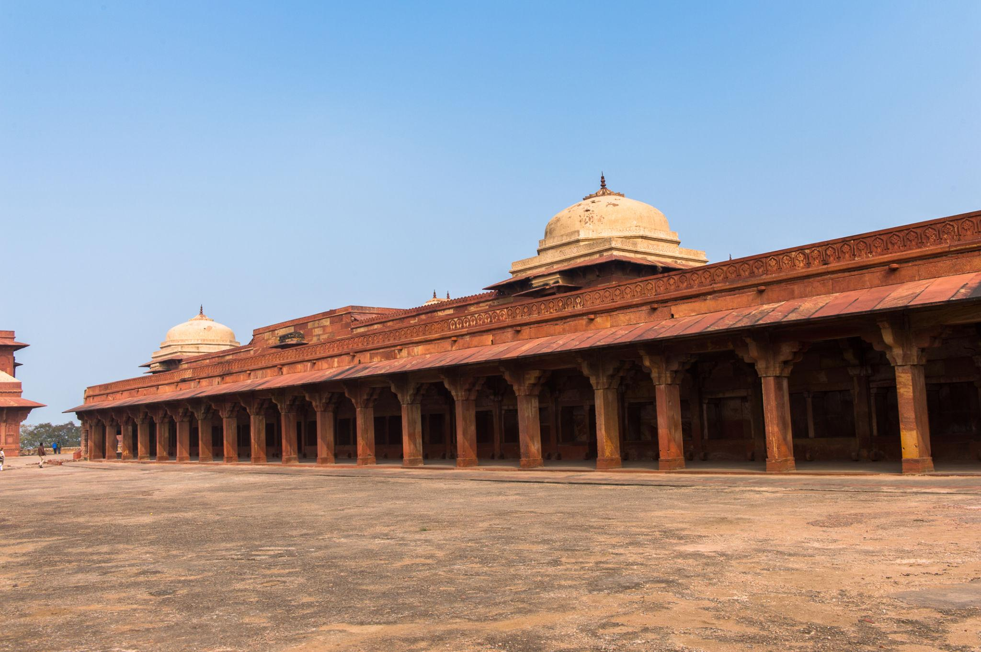
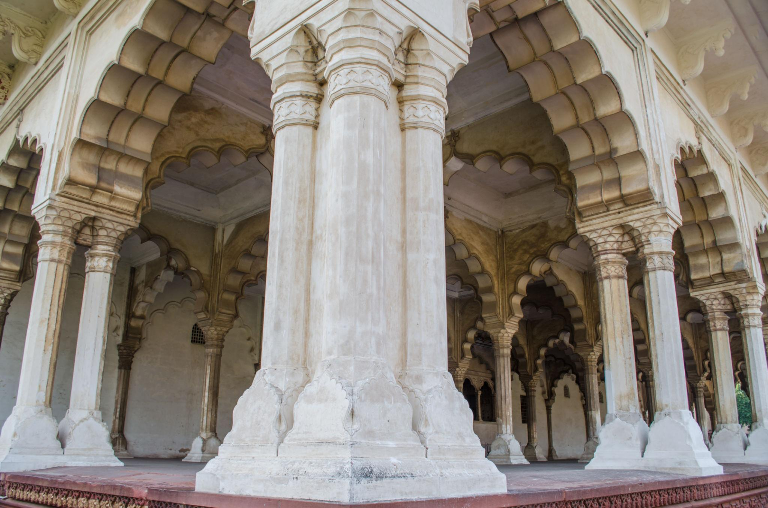
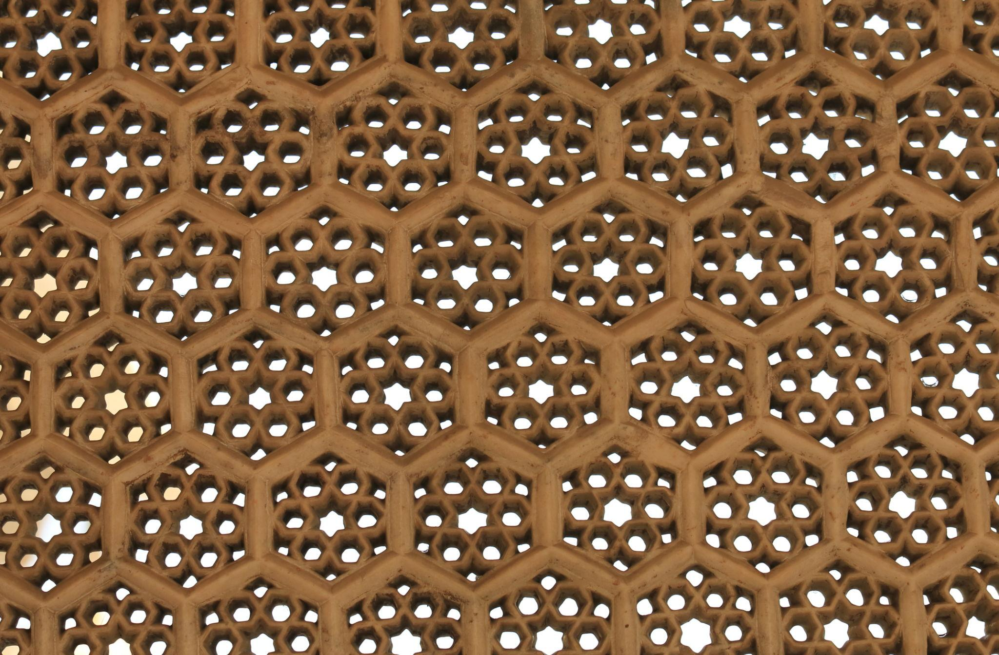
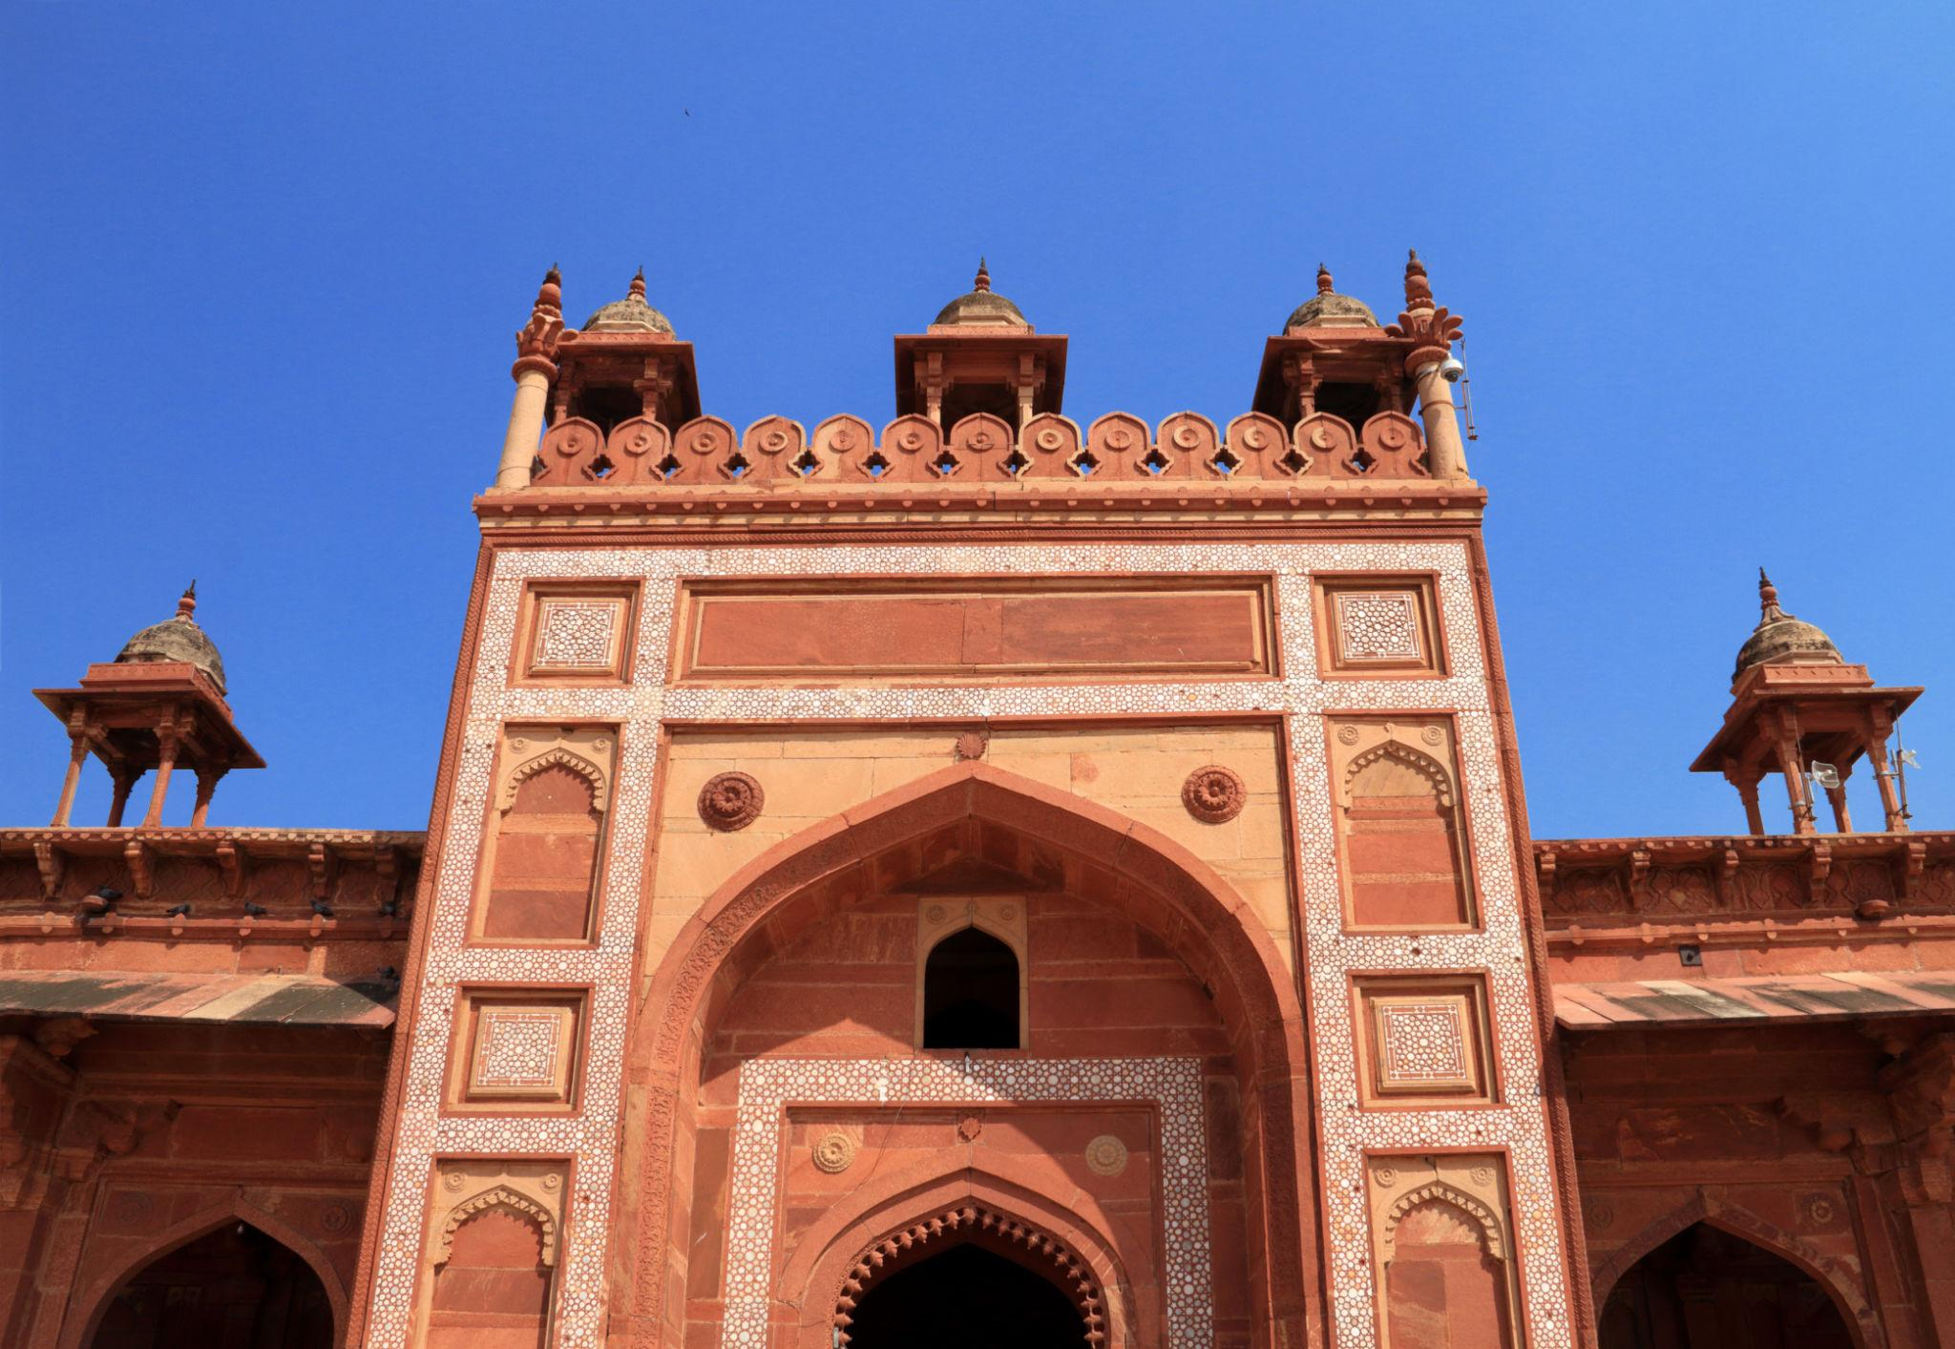

5. Itimad-ud-Daulah
Often called the “Baby Taj,” this beautiful Mughal tomb is known for delicate marble artwork.
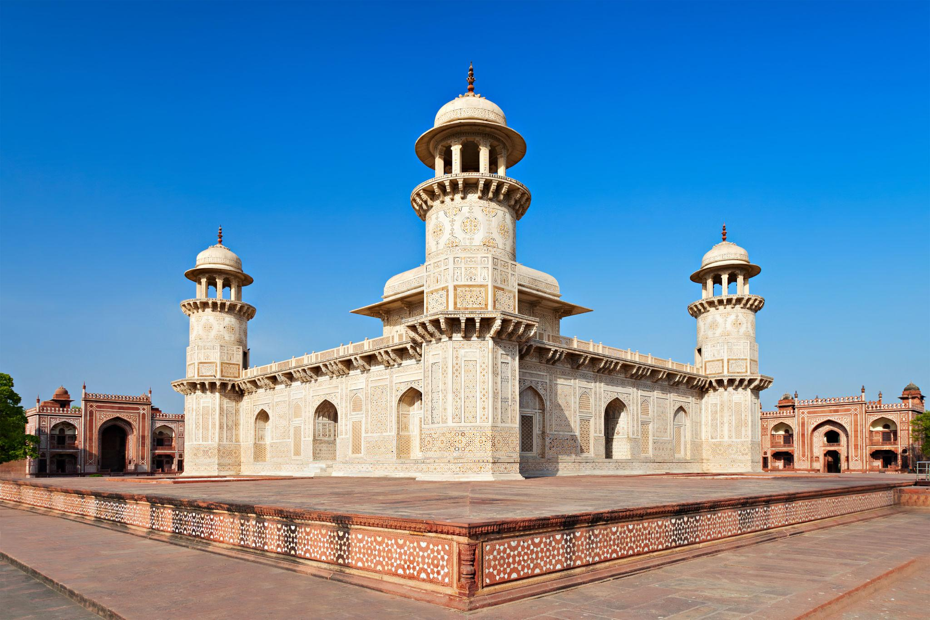
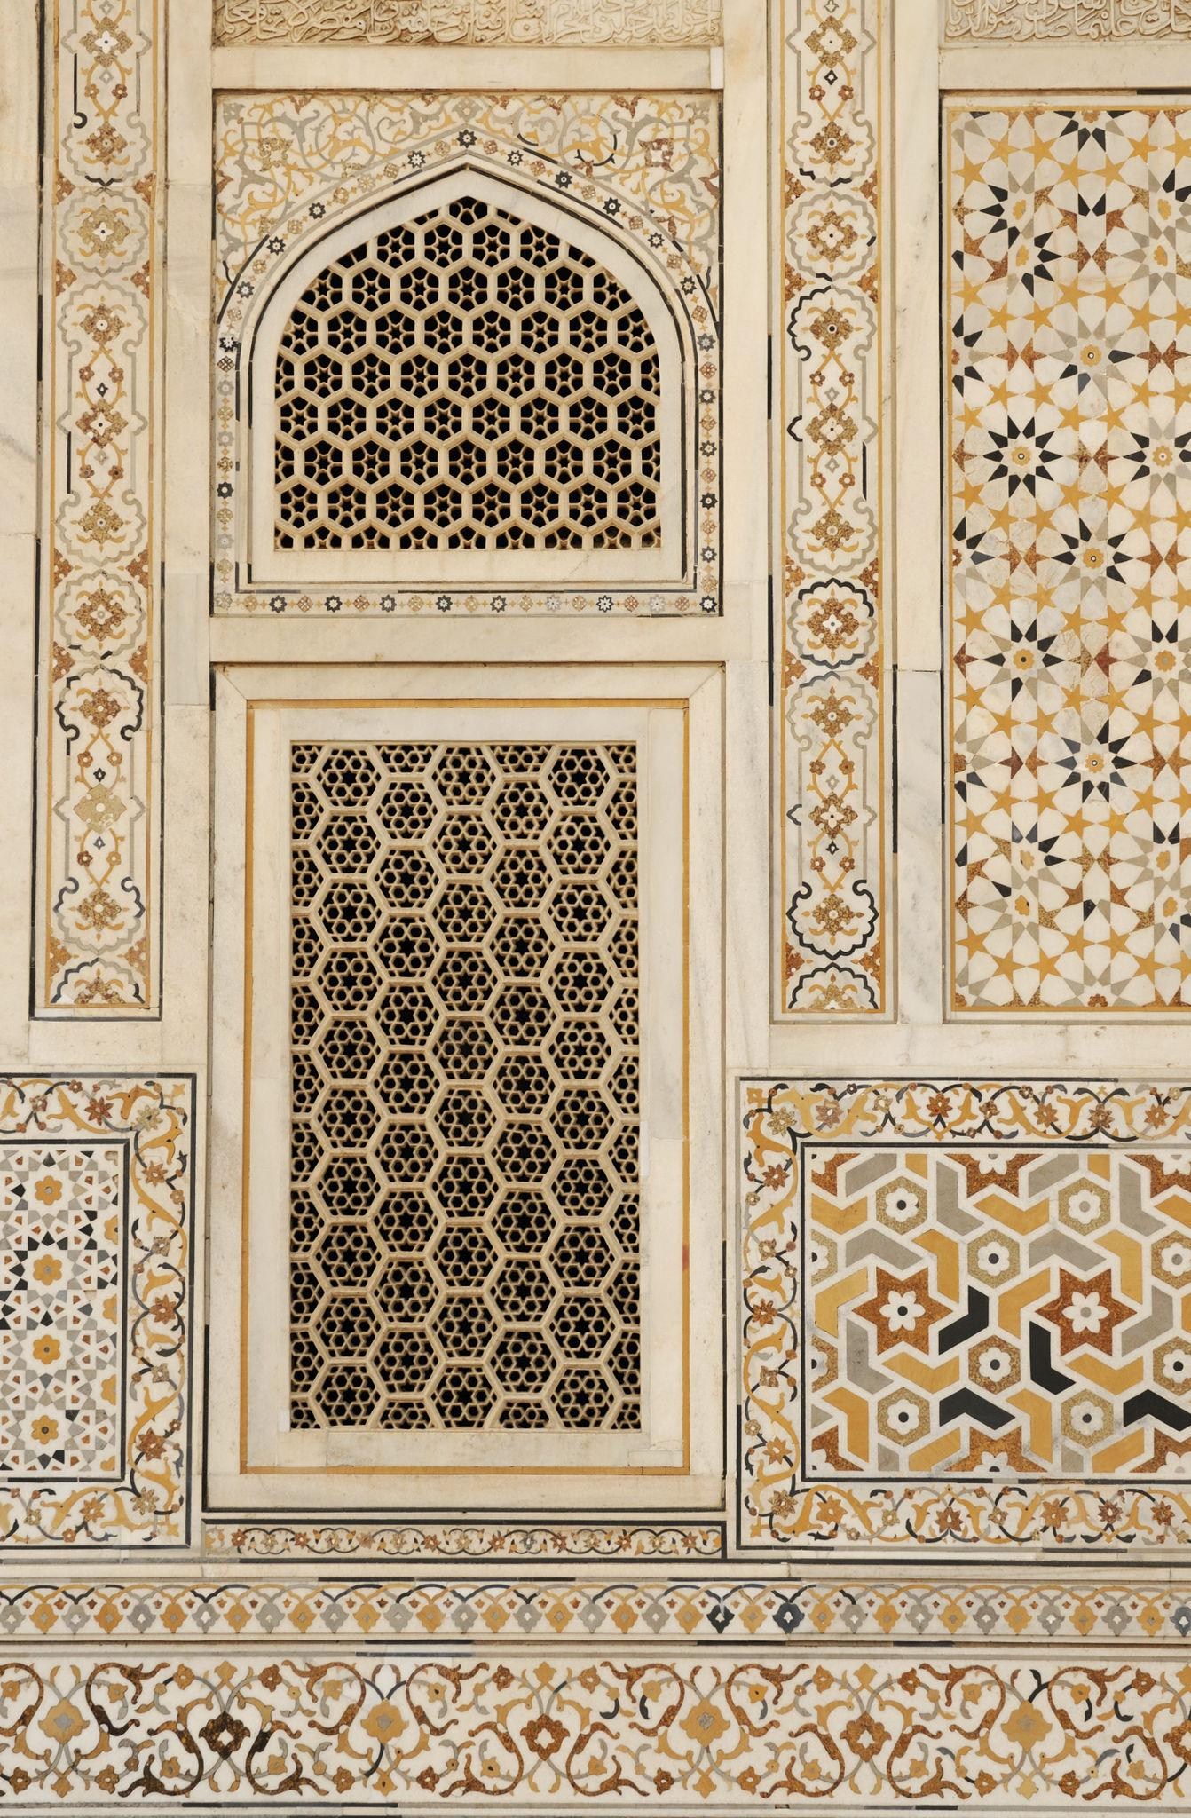
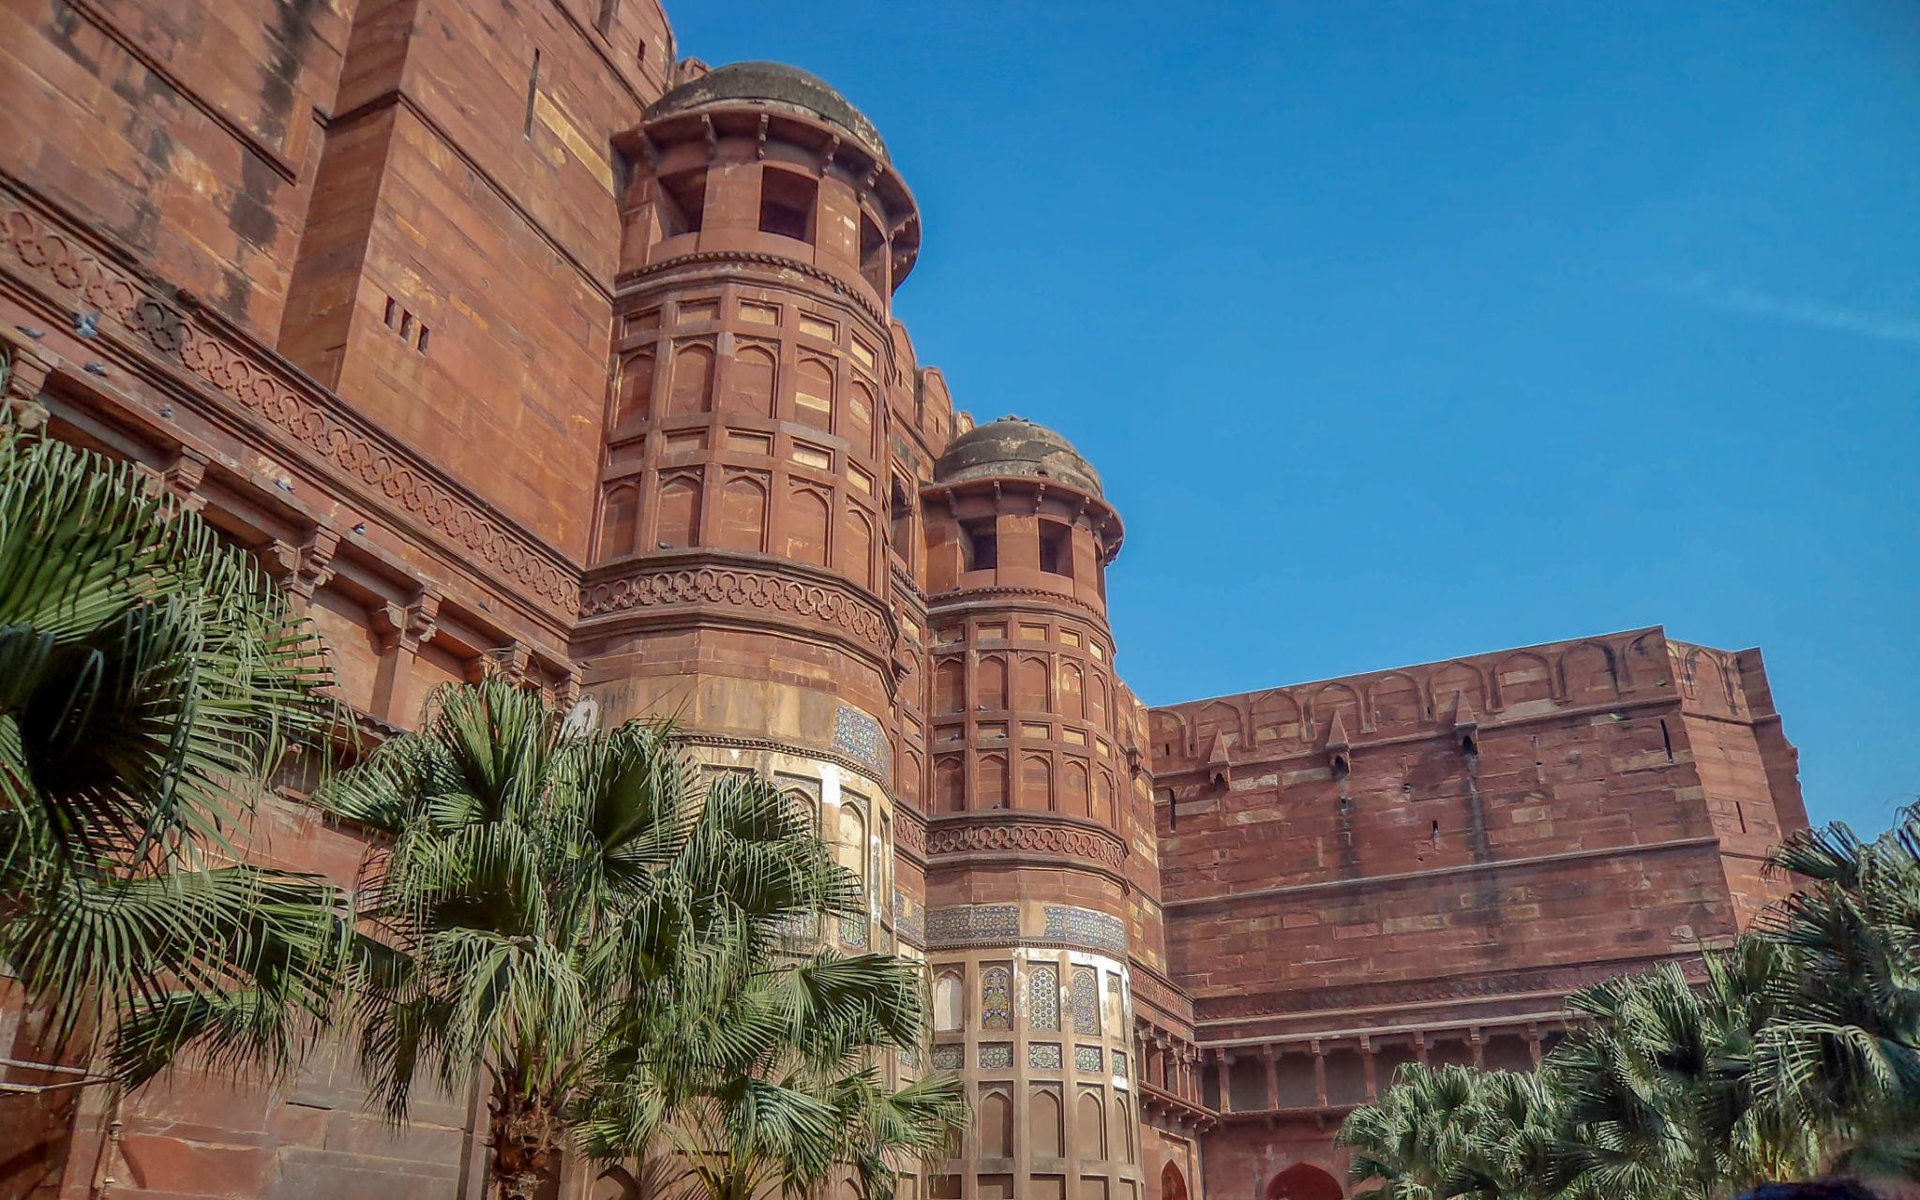

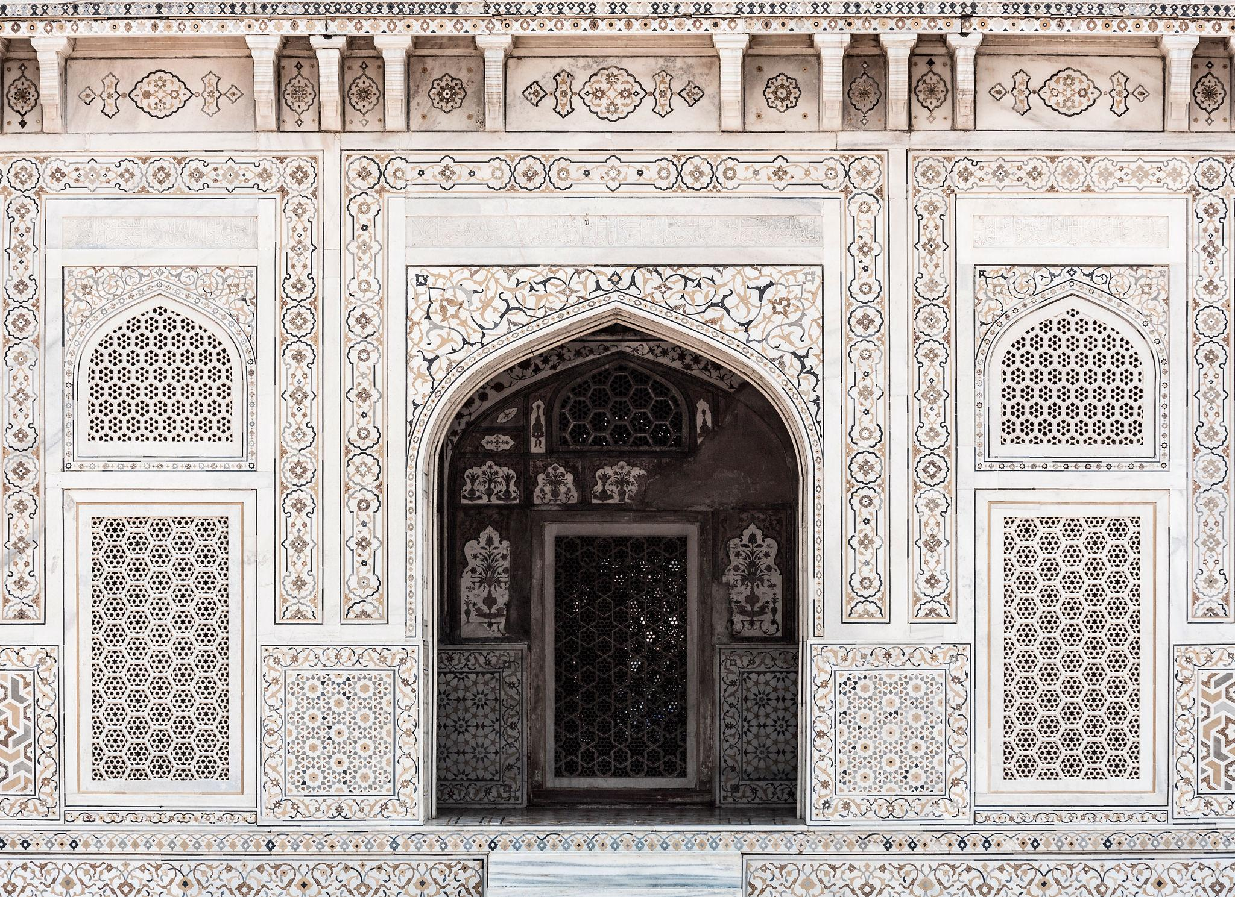
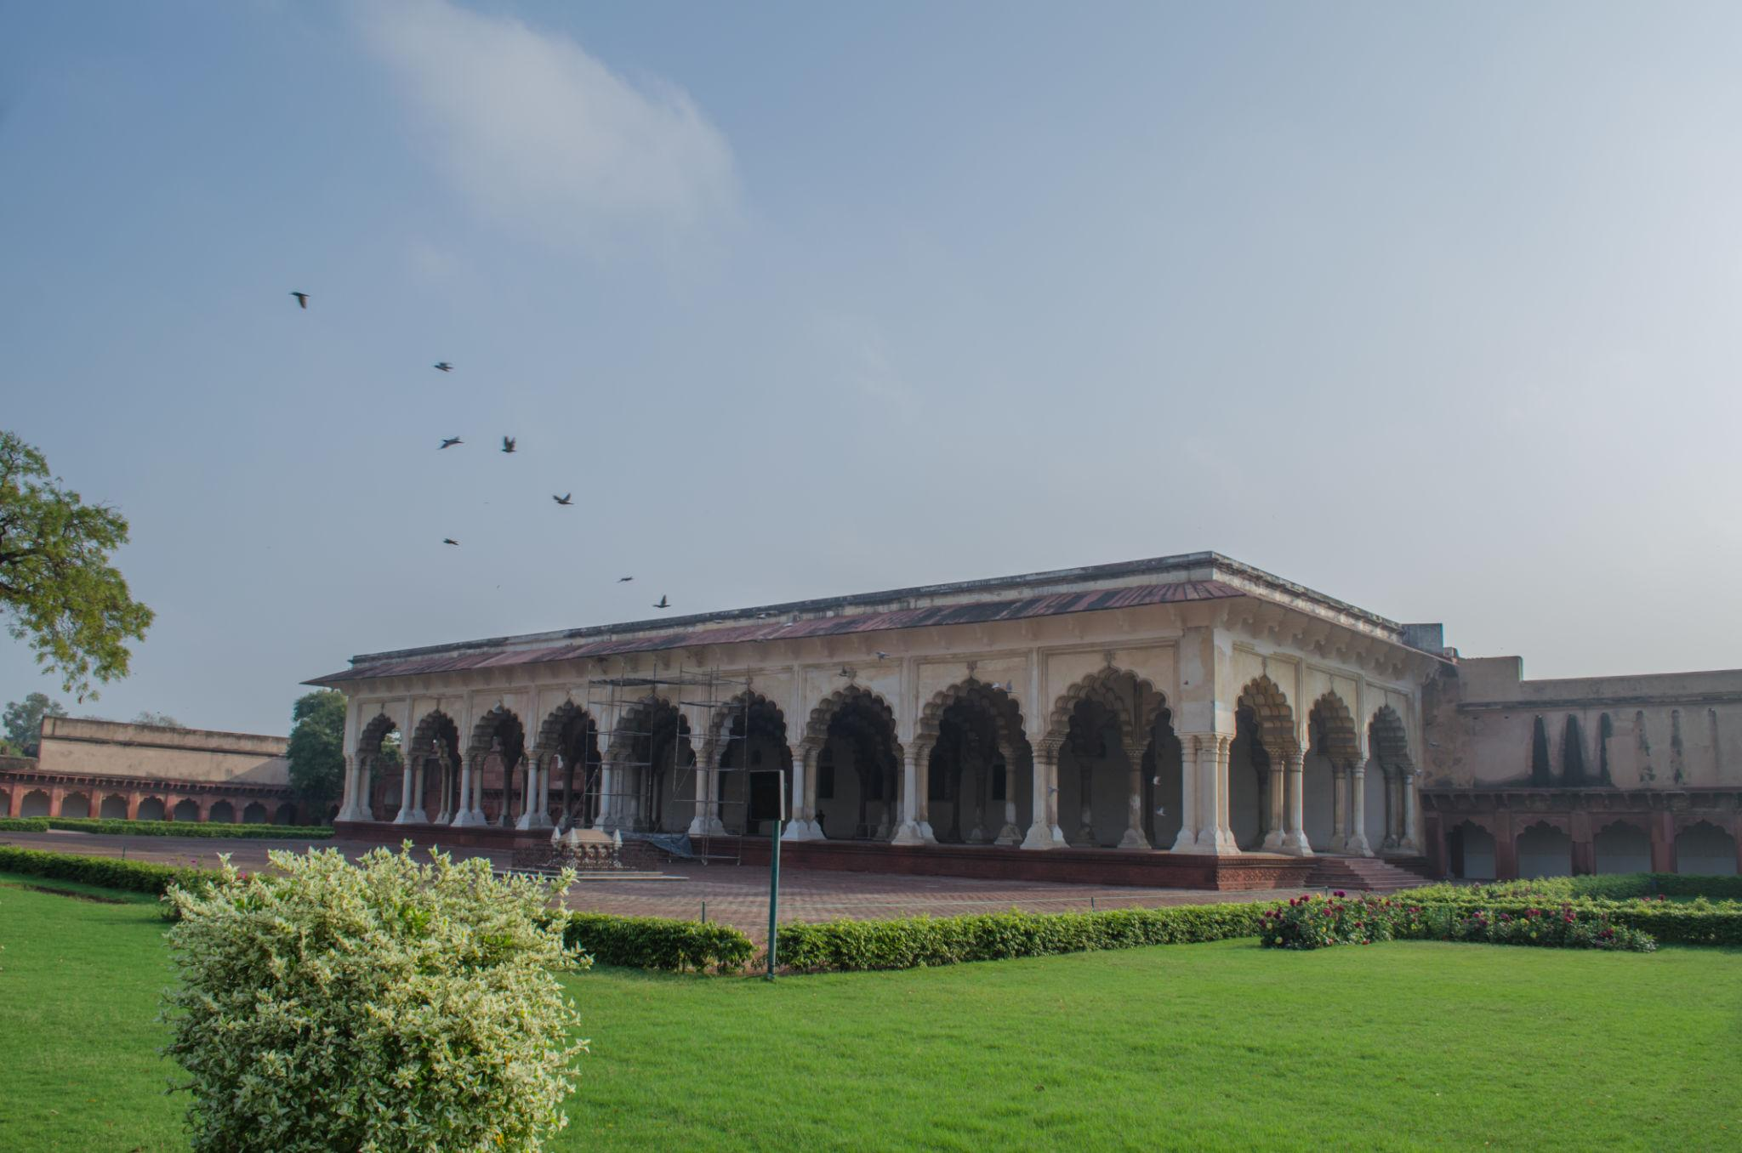

Best Things to Do in Agra
- Watch sunrise at the Taj Mahal
- Explore Mughal forts & palaces
- Enjoy local Mughlai cuisine
- Shop for marble handicrafts & leather goods
- Visit Mehtab Bagh for sunset photography
- Explore local bazaars
- Take heritage walks
- Experience Agra’s cultural history

Best Time to Visit Agra
Season | Months | Weather
Winter | October – March | Pleasant & best for sightseeing
Summer | April – June | Very hot
Monsoon | July – September | Moderate rain & greenery
The best time to visit Agra is during the winter season.

How to Reach Agra
By Train
Agra is well connected by rail from:
- Delhi
- Jaipur
- Mumbai
- Varanasi
By Road
Agra is connected through:
- Yamuna Expressway from Delhi
- National highways
Travel time from Delhi: approximately 3–4 hours by road.

Famous Foods to Try in Agra 🍴
- Mughlai Biryani
- Kebabs
- Bedai & Jalebi
- Petha (Agra’s famous sweet)
- Parathas
- Tandoori dishes
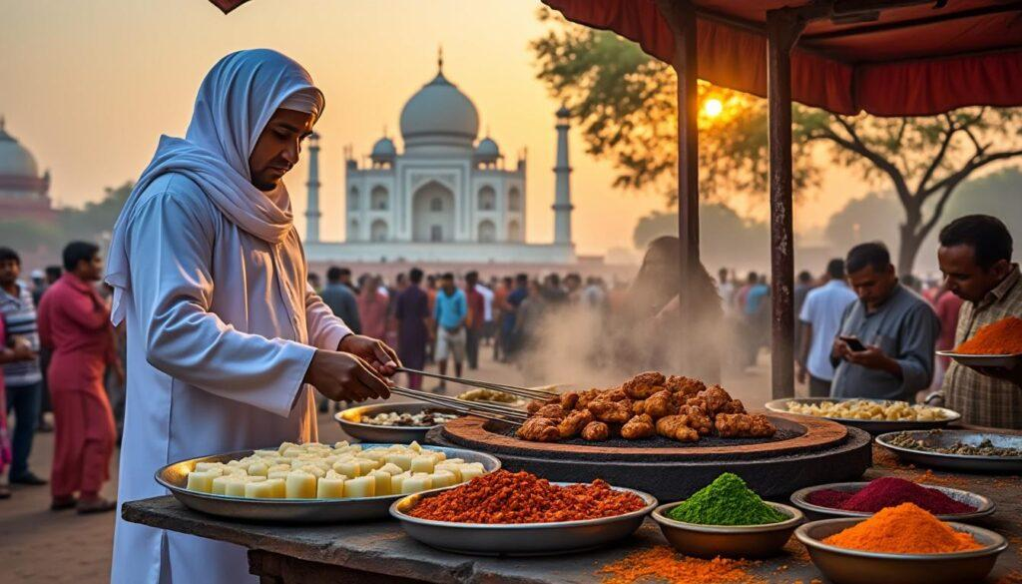
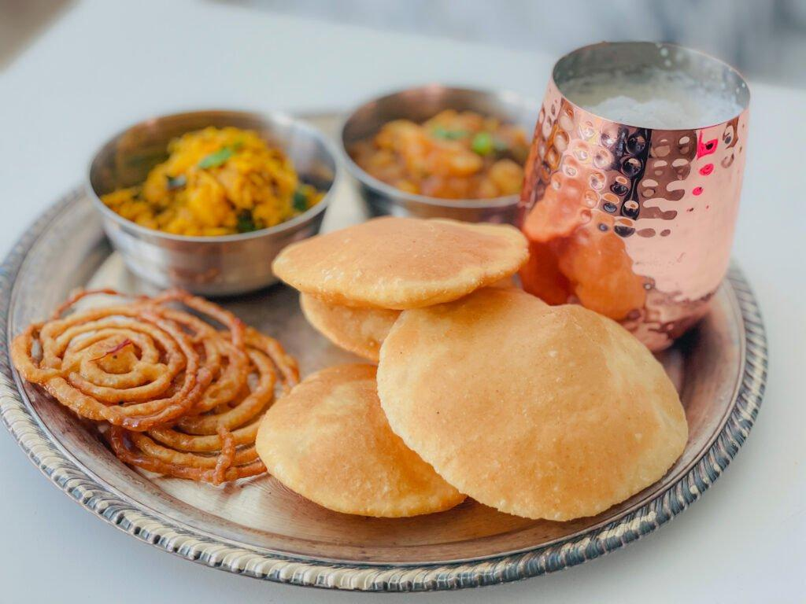
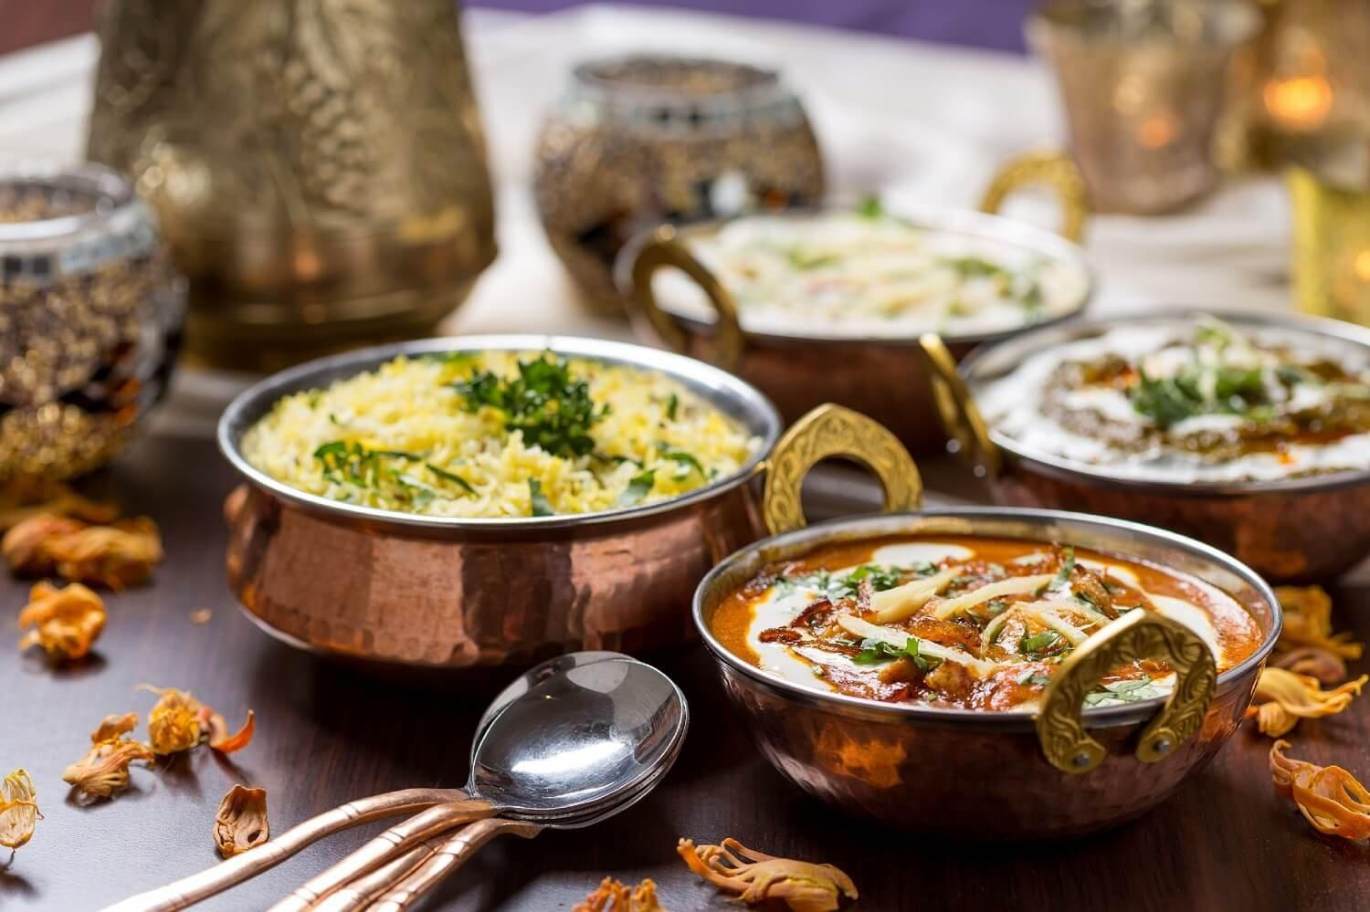
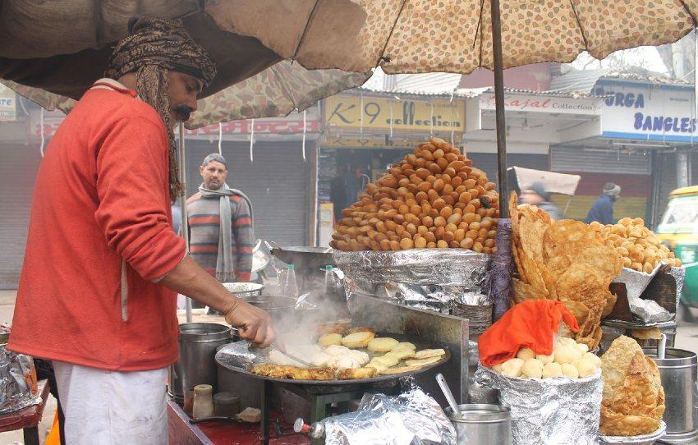
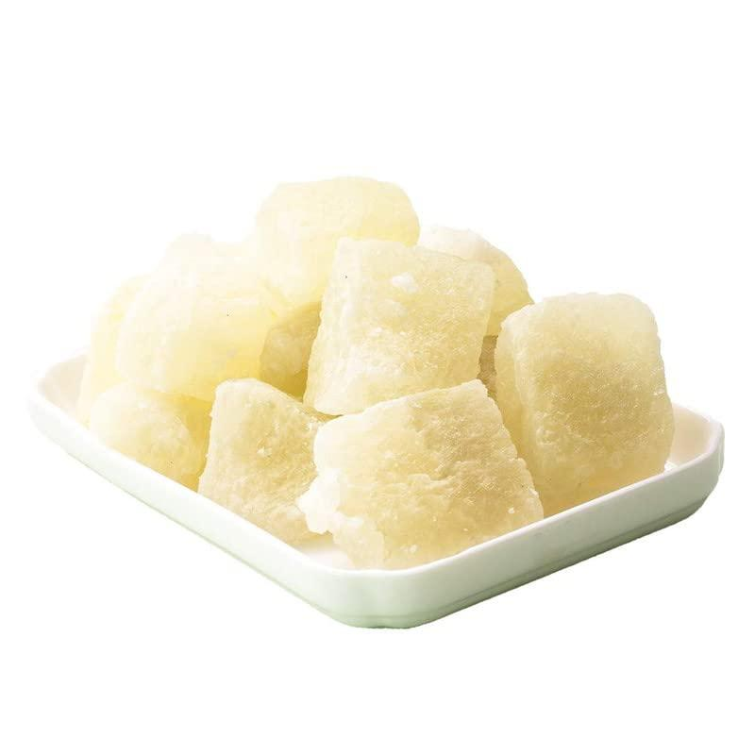
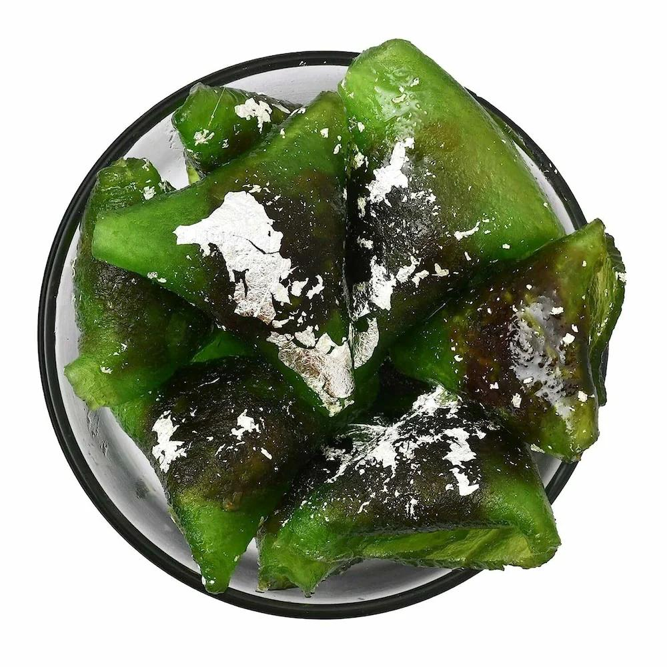
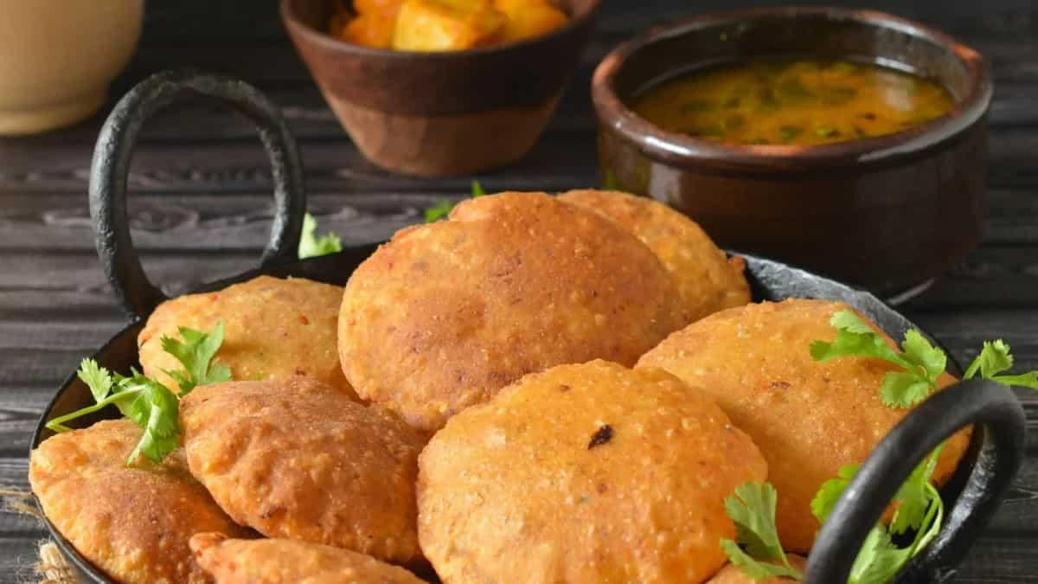
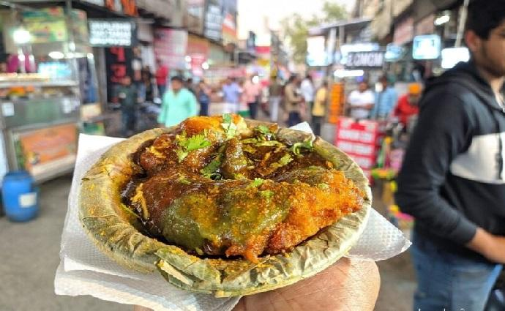
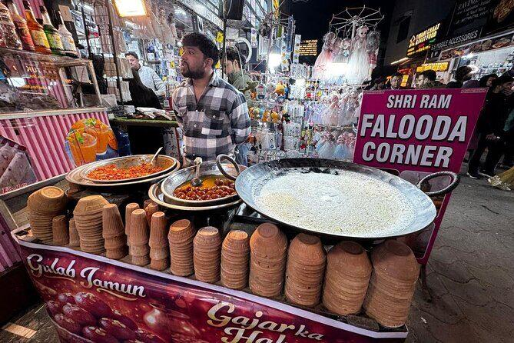

Shopping in Agra 🛍️
Agra is famous for:
- Marble handicrafts
- Leather products
- Handicrafts
- Traditional jewelry
- Carpets & textiles
Popular shopping areas:
- Sadar Bazaar
- Kinari Bazaar
- Taj Ganj Market
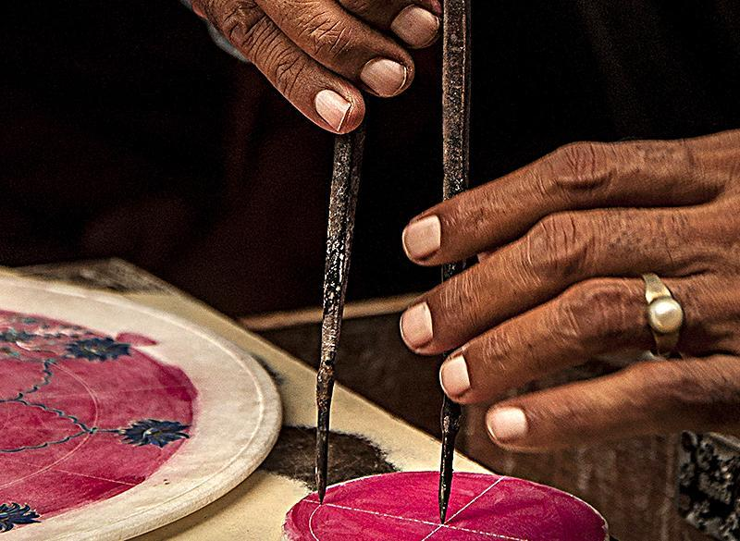
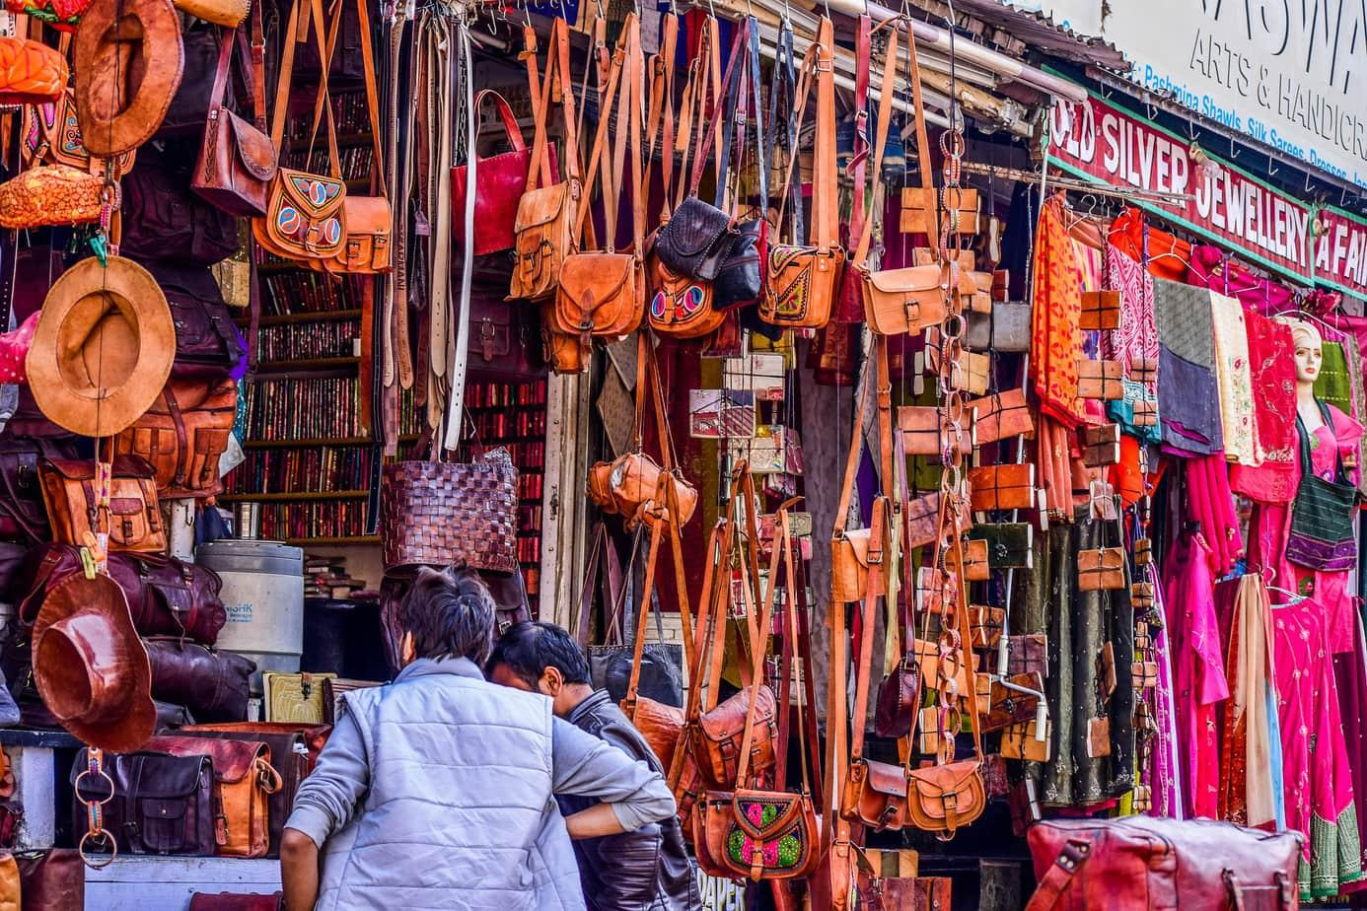
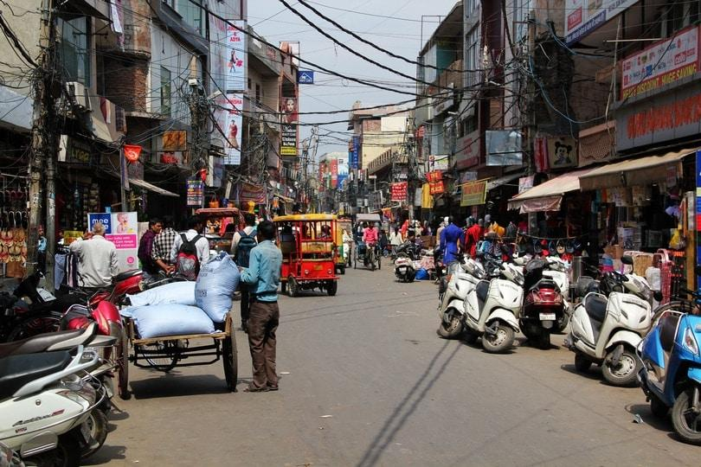
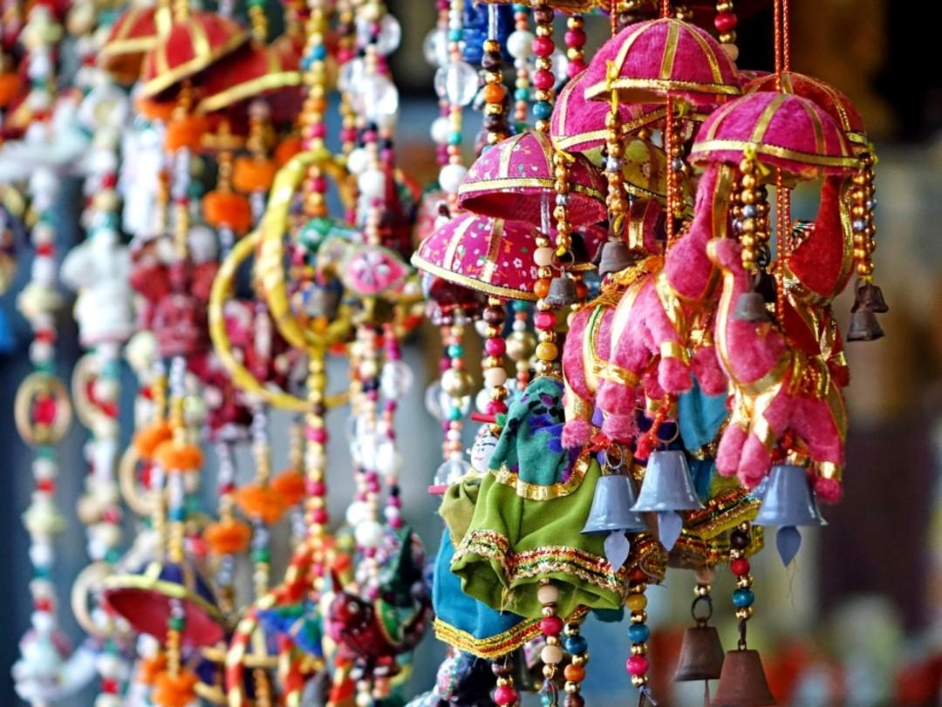
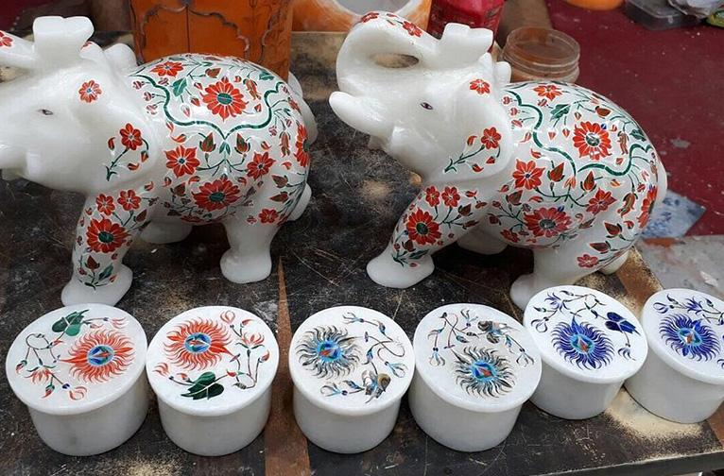
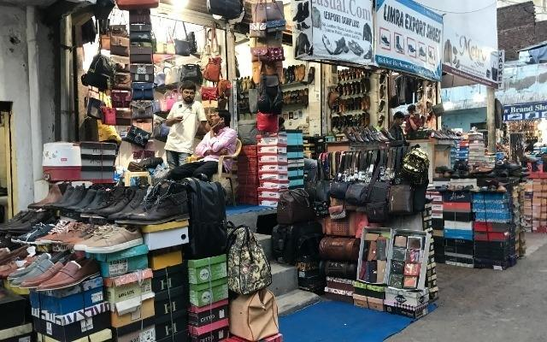
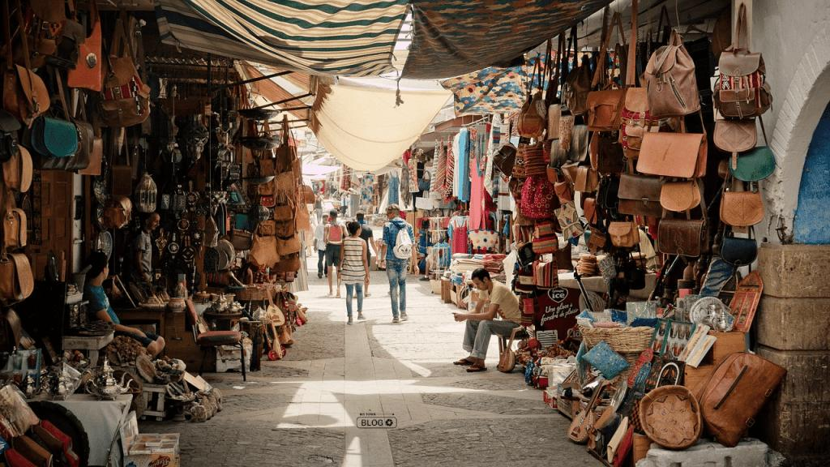

Agra Travel Tips
- Visit Taj Mahal early morning to avoid crowds
- Carry comfortable walking shoes
- Avoid carrying restricted items into monuments
- Stay hydrated during summer
- Hire licensed local guides
- Keep camera ready for sunrise photography

Why Choose INTRO TRAVELS INDIA for Agra?
With INTRO TRAVELS INDIA, you get:
- Customized Agra holiday packages
- Heritage & cultural tours
- Budget & luxury hotel options
- Comfortable transport arrangements
- Guided sightseeing tours
- Family & honeymoon packages
- Local food experiences
- Weekend getaway plans
Agra is a destination where timeless Mughal architecture, rich heritage, romance, and Indian culture come together to create a truly unforgettable journey. ✨🏛️

